 | 
COUNCIL ASSESSMENT REPORT
NORTHERN REGIONAL PLANNING PANEL

PANEL REFERENCE & DA NUMBER | PPSNTH-427 – BYRON – 10.2025.212.1
PROPOSAL | Amended DA - Demolition of public toilets (heritage item), car park and tree removal. Affordable housing mixed use development comprising shop top housing (28 apartments above ground level), one ground floor commercial premises and ground floor boarding house, carparking, landscaping and associated services.
ADDRESS | Lots 6, 7 & 8, Section 3 DP 2772 – 57 Station Street Mullumbimby
APPLICANT | Wilson Planning (on behalf of Landcom)
OWNER | Byron Shire Council
DA LODGEMENT DATE | Original DA lodgement - 25/06/2025  Amended DA#1 lodgement – 16/06/2026
PUBLIC EXHIBITION | Original DA – 3/7/2025 to 3/8/2025  Amended DA – 22/6/2026 to 16/8/2026
APPLICATION TYPE | Crown Development
/REGIONALLY SIGNIFICANT CRITERIA | Clause 4 Schedule 6 of State Environmental Planning Policy (Planning Systems) 2021: Crown Development over $5 million
C to IV | $16,521,743.00
CLAUSE 4.6 REQUESTS | No applicable
KEY SEPP/LEP | Relevant Environmental Planning Instruments  - State Environmental Planning (Biodiversity and Conservation) 2021  - State Environmental Planning Policy (Housing) 2021  - State Environmental Planning Policy (Planning Systems) 2021  - State Environmental Planning Policy (Resilience and Hazards) 2021  - State Environmental Planning Policy Sustainable Buildings) 2022  Local Environmental Plan  - Byron Local Environmental Plan 2014  Relevant Development Control Plan  - Byron Development Control Plan 2014
TOTAL & UNIQUE SUBMISSIONS KEY ISSUES IN SUBMISSIONS | No. of submissions  Original DA  Total – 724  Objection – 719  Support – 5  Template submissions - 404  Amended DA  Total – 1,768  Objection – 1,767  Support – 1  Template submissions - 883  Issues in submissions  - Sewer main  - Flooding and stormwater  - Infrastructure capacity  - Powerlines  - Waste management  - Rear access to restaurants in Burringbar Street  - Loss of public car park  - Construction and operational traffic  - Car parking  - Loss of heritage listed toilet  - Height, bulk and scale  - Solar access  - View loss  - Visual amenity  - Landscaping  - Consultation and transparency  - Alternative sites  - Community housing provider uncertainty  - Business disruption  - Social and economic impacts
DOCUMENTS SUBMITTED FOR CONSIDERATION | - Planning Report and Attachments  - Statement of Environmental Effects  - Landscape Design Report  - Architectural Drawings
SPECIAL INFRASTRUCTURE CONTRIBUTIONS (S7.24) | Not applicable
RECOMMENDATION | Approval subject to conditions
DRAFT CONDITIONS TO APPLICANT | Sent to applicant 1/10/2026  Approved by applicant 6/10/2026
SCHEDULED MEETING DATE | 19 October 2026
PLAN VERSION
  Title | Plan No. | Drawn by | Dated
  Cover Page | A0.01, Rev D | Architect Hill Thalis | 28/09/2026
  Mullumbimby Aerial | A1.01, Rev A | Architect Hill Thalis | 26/03/2025
  Mullumbimby Context – Council Policies | A1.02, Rev A | Architect Hill Thalis | 26/03/2025
  Site Context Plan | A1.03, Rev A | Architect Hill Thalis | 26/03/2025
  Site Controls and Calculations | A1.04, Rev C | Architect Hill Thalis | 28/09/2026
  Demolition Plan | A2.01, Rev A | Architect Hill Thalis | 26/03/2025
  Ground Floor Plan | A2.02, Rev D | Architect Hill Thalis | 28/09/2026
  Level 1 Floor Plan | A2.03, Rev C | Architect Hill Thalis | 28/09/2026
  Level 2 Floor Plan | A2.04, Rev C | Architect Hill Thalis | 28/09/2026
  Roof Plan | A2.05, Rev B | Architect Hill Thalis | 28/05/2026
  Accessible Unit Layouts | A2.10, Rev B | Architect Hill Thalis | 26/03/2025
  Scale Precedence | A2.20, Rev A | Architect Hill Thalis | 28/05/2026
  Elevations | A2.21, Rev D | Architect Hill Thalis | 28/09/2026
  Elevations | A2.22, Rev D | Architect Hill Thalis | 28/09/2026
  Sections | A2.31, Rev D | Architect Hill Thalis | 28/09/2026
  Sun Analysis – Winter Solstice | A4.01, Rev B | Architect Hill Thalis | 26/03/2025
  Shadow Analysis – Winter Solstice | A4.02, Rev B | Architect Hill Thalis | 28/05/2026
  11.7m Height Plane | A5.01, Rev B | Architect Hill Thalis | 28/05/2026
  Materials | A6.01, Rev C | Architect Hill Thalis | 28/05/2026
PREPARED BY | Greg Yopp – Consultant Planner
DATE OF REPORT | 6 October 2026

EXECUTIVE SUMMARY

The amended development application seeks consent for the demolition of public toilets (heritage item), car park and tree removal; and the construction of a three storey building to be used as a mixed use development comprising ground floor car parking, four room boarding house and twenty-eight shop top housing apartments located on level one and two. Twenty-four of the twenty-eight shop top housing apartments are proposed as affordable housing pursuant to SEPP (Housing) 2021. The proposal also includes ancillary civil works and landscaping.
The subject site comprises Lots 6, 7 & 8, Section 3 in DP 2772 and is known as 57 Station Street Mullumbimby. The site has a total are of 1,691m² and is rectangular in shape. The site has a 30m eastern frontage to Station Street and McGoughans Lane to the west. The land is owned by Byron Shire Council and is used as a public car park with forty-three parking spaces. A concrete footpath adjoins the site in Station Street.
The land is flood prone with a Flood Planning level of 5.14m AHD. The site is currently not burdened by any easements, however, there is a sewer main running the full width of the site generally parallel to and approximately 1.5m from the southern boundary. Overhead powerlines run north south along both Station Street and McGoughans Lane frontages.

The site is relatively level with a slight fall from west to east of approximately 300mm. The land is bitumen sealed with some garden beds and approximately 40 small trees and shrubs within the site or on the boundary.

The land is within the Mullumbimby Heritage Conservation Area and is Zoned E1 Local Centre. Land to the south and west are also within Zone E1. The adjacent northern allotment is also within Zone E1, land further to the north is within Zone R2 Low Density Residential. Surrounding dwellings to the north and east are generally single or double storey. Town centre commercial buildings are comprised of a mixture of single and double storey.

Relevant Environmental Planning Instruments include SEPP (Biodiversity and Conservation) 2021, SEPP (Housing) 2021, SEPP (Planning Systems) 2021, SEPP (Resilience and Hazards) 2021; SEPP (Sustainable Buildings) 2022 and Byron LEP 2014. The NSW Apartment Design Guide and Byron DCP 2014 also apply.

The original DA was lodged on 25/06/2025 and an amended DA was lodged on 16/06/2026. The amended DA provided requested additional information, however, it was still inconsistent with the design and/or heritage provisions of SEPP (Housing) 2021, LEP 2014 and DCP 2014. The amended DA was modified and amended plans were submitted on 29/09/2026 (Amended DA#2). Amended DA#2 includes design changes to the Station Street façade and footpath and landscaping works in Station Street. The proposal is now considered to be consistent with the relevant SEPP’s, LEP 2014 and DCP 2014.

There were no concurrence requirements from agencies for the proposal, and the application is not integrated development pursuant to Section 4.46 of the Environmental Planning and Assessment Act 1979 (‘EP&A Act’). It is a Crown development application pursuant to Division 4.6 of the EP&A Act 1979; and Regionally Significant Development pursuant to Schedule 6 Clause 4 of SEPP (Planning Systems) 2021.

The development application was referred to Essential Energy due to the proximity of overhead powerlines and plans to underground some of the infrastructure. No issues were raised and an approval pathway exists for this aspect of the proposal.

The original development application was placed on public exhibition from 3/7/2025 to 3/8/2025. The amended Development application was placed on public exhibition from 26/6/26 to 16/8/26.

An overview of submission numbers is provided below.
Note. Multiple submissions by same person counted as a single submission
Exhibition | Template submissions | Total submissions | Total objections | Total support | Multiple submissions by one person/group
Original DA | 404 | 724 | 719 | 5 | 58
Amended DA | 883 | 1,768 | 1,767 | 1 | 31

These submissions raised issues relating to infrastructure and servicing; loss of public car park and public toilet; site constraints; traffic, parking and access; built form, heritage and amenity; governance and process; and social and economic impacts. These issues are considered further in this report.

The application is referred to the Northern Regional Planning Panel as the development is ‘regionally significant development’, pursuant to Section 2.19(1) and Clause (4) of Schedule 6 of State Environmental Planning Policy (Planning Systems) 2021 as the proposal is Crown development with a CIV over $5 million.

All of the key issues related to the proposal have either been resolved with additional information; modified plans; or recommended conditions of consent.

The key issues associated with the proposal included:

Sewer main
A Council sewer main runs parallel to, and approximately 1.5m from, the southern boundary. The original proposal was generally setback 3.0 from the southern boundary, with one element of the building with zero southern setback. The issue is resolved with the amended proposal and the conditions of consent. The building is now setback 3.6m from the southern boundary.

Flooding and stormwater
The subject allotment is in the flood planning area. All habitable rooms are above the flood planning level. The issue is resolved with the provision of additional information and appropriate conditions of consent.

Powerlines
The proposal was referred to Essential Energy in accordance with the previous requirement of SEPP (Transport and Infrastructure) 2021 (now SEPP (Planning Systems) 2021). Essential Energy had no comments to make in relation to potential safety risks arising from the proposed development, subject to the relocation / replacement of overhead conductors on the eastern and western sides of the proposed development as outlined in the Powerlines Concept Plan submitted with the amended DA.

Waste management
The proposed waste collection involves using a private contractor from McGoughans Lane. There is a loading bay within the property boundary that will accommodate a waste collection vehicle (SRV). Bin areas are located in a fenced area within the car park. There is currently no Council bin collection in McGoughans Lane which is a 6m wide road reserve. Preliminary discussion with Council Waste Officers indicates that waste collection in McGoughans Lane is feasible. Appropriate conditions of consent are recommended.

Rear access for restaurants in Burringbar Street
The amended DA was lodged on 16/06/2026 and one of the modifications included setting the building back 3.6m from the southern boundary in order to create an easement over the sewer main that generally runs parallel to, and 1.5m to the north of, the southern boundary. Council’s Legal Counsel has been in discussions with the owner of the land within which the businesses are located (Lot 3 Section 3 DP 2772). It is possible to locate an access easement within the sewer easement that would benefit Lot 3 Sec 3 DP 2772, however this will be a matter for the landowner to pursue with Council as the other land owner.

Loss of public car park
The proposed development is located on a public car park providing 43 spaces.
Byron Shire Council Operation Plan (OP) 2026-27 includes provision for alternative arrangements for parking in the Mullumbimby Rail Corridor. The Byron Shire Local Infrastructure Contributions Plan 2026 includes Mullumbimby railway land car parking as a line item in the works schedule. Council’s Mullumbimby concept car parking plans are provided in Section 5 of the report.

Loss of heritage listed public toilets
Two issues are considered below, being, the loss of a locally heritage listed building; and the loss of public toilets.

Heritage
A Heritage listed public toilet (LEP Schedule 5) designed by Byron Bay based architect Christine Vadaz, particularly active in the profession from the 1980’s onward, is located within the subject site.

An appropriate strategy to deal with the proposed demolition is to condition the consent requiring: a) an archival report of the heritage item; and b) the preservation of the roof for reuse in a future small scale civic building such as a gazabo/ picnic shelter or the like, preferably in Mullumbimby as opposed to complete demolition. Council’s asset management staff have been informed of the circumstances and short-term storage is possible while an appropriate reuse is decided upon.

Loss of public toilets

Public toilets available in Mullumbimby town centre include:
- Mullumbimby Tennis Club Recreation Ground – toilets are located within the fenced enclosure and are part of the tennis club. Additionally, public toilets are located outside of the fenced enclosure.
- Mullumbimby Civic Centre Memorial Hall – toilets are available within the building for public use. However, opening times vary depending on a specific concert, market or function booked.
- 57 Station Street within the public car park (proposed for demolition) –
- Byron Shire Council Administration building – open within normal office hours

The Byron Shire Local Infrastructure Contributions Plan 2026 includes a new Mullumbimby amenities block, including hot showers and solar, is a line item in the works schedule. A site for the amenities block is yet to be determined, however, it is planned for an “in town” location.

Construction and operational traffic and car parking
Council’s Development Engineer reviewed the traffic reporting and concluded that operational traffic would generate a low impact to the existing road network.
The matter of construction traffic can be dealt with as a condition of consent prior to the issue of a Crown Certificate. Other relevant conditions of consent are also recommended in relation to the construction of the development.

Solar access for south facing restaurants
The Apartment Design Guide Section 3B-2 applies – Overshadowing of neighbouring properties is minimised mid-winter. Byron DCP D1.2.1 – Building Height Plane does not apply to shop top housing (refer to Prescriptive Measure 1 of that section of the DCP).
The assessment of solar access for adjoining southern allotments is considered satisfactory and does not require additional conditions of consent.
The amended DA relocated the entire building 0.7m further from the southern boundary. The southern setback is 3.6m with the central part of the building setback approximately 8m. The proposed 3.6m-8m setback from the southern boundary in Zone E1 Local Centre is very generous and also serves to minimise overshadowing on the adjacent commercial premises. The northern portion of No. 68, 70, 76 & 78 Burringbar Street, are all used for private car parking and not for outdoor open space. No 72 is occupied by two restaurants where the vegetated northern portion of the lot is used for alfresco dining. In this location, the adjoining proposed northern building is setback approximately 8m. The alfresco dining area would receive in excess of 3 hours solar access during the winter solstice. Moreover, most of the solar access is achieved between 10am to 1.30pm, likely peak lunch times for diners.
The assessment of solar access for adjoining southern allotments is considered satisfactory and does not require additional conditions of consent.

Business disruption
Council’s Environmental Officer and Development Engineer have assessed the proposal and reports related to their disciplines and they are satisfied that negative impacts on surrounding existing development can be mitigated with the recommendation of appropriate conditions of consent.

Bulk and scale of the building
Various meetings and correspondence with the applicant and their team have occurred subsequent to the initial date of lodgement, being 25/6/2025. The applicant was requested to amend the plans to, inter alia, relocate the building off the sewer main and to reduce the bulk and scale of the building from the Station Street façade. An amended DA was lodged on 16/6/2026. The amended DA satisfied various requests for additional information and relocation of the building further to the north away from the sewer main. However, the Station Street façade was generally not modified.
A further request to amend the plans to reduce the Station Street façade bulk and scale was issued to the applicant on 15/7/26; and followed up with a meeting on 25/9/2026; and amended plans were submitted to Council on 29/9/2026. The amended plans have generally addressed the Station Street bulk and scale matter with: the elimination of part of the second level verandah; increased front setback; and footpath and landscaping works in Station Street. Additionally, the use of F/C cladding or similar with a soft colour palate, via a recommended condition of consent, will also be used to clad the building in association with the proposed galvanised iron and masonry. These modifications are more compatible with the aesthetic character of the Mullumbimby Heritage Conservation Area.

Crown Development
The conditions of consent were referred under Section 4.33 of the EPA Act 1979. Landcom on behalf of the Minister has agreed to the conditions of consent in Attachment A.

Conclusion
Following a detailed assessment of the proposal, pursuant to Section 4.16(1)(a) of the EP&A Act, DA 10.2025.212.1 is recommended for approval subject to the conditions of consent contained at Attachment A of his report.

- THE SITE AND LOCALITY

  - The Site

The site comprises three land parcels, Lots 6, 7 and 8 on Section 3 of DP2772, which is Council-owned Operational Land and currently provides forty three (43) public car parking spaces and a public lavatory. It is included in the E1 Local Centre Zone of the Byron LEP 2014, and has a combined total area of 1,691m². A Council sewer main runs parallel to and the length of the southern property boundary, and Essential Energy overhead infrastructure runs parallel and close (within 2m) to the Station Street and McGoughan’s lane frontages. Figure 1 provides and aerial view of the site.
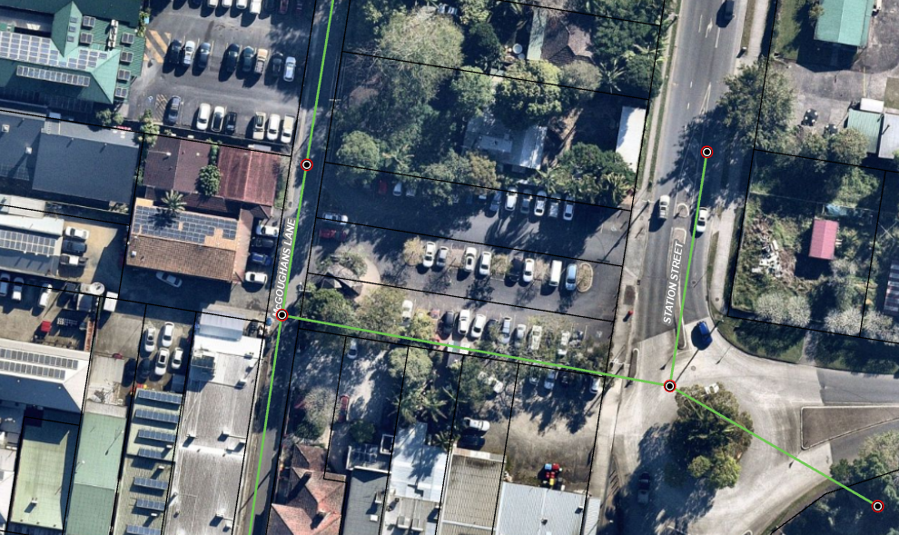
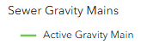
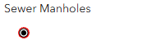
Figure 1 – Aerial View of Site
Essential energy overhead powerlines
Development site

The site is rectangular in shape, with east-facing frontage to Station Street and West-facing frontage to McGoughan’s Lane. The land is predominantly flat with an average height of 4.3m AHD and a minor fall to the Station Street frontage. Five (5) landscaping beds planted with native species spread through the centre of the site. Mature vegetation (up to 11 trees) grows along the southern boundary which includes a mix of native and introduced species, and up to six (6) mature trees comprising a mix of native and introduced species straddle the northern boundary line.
The property is identified as Flood liable land containing Acid Sulfate Soils (Class 4) and is in the Coastal Environment Area under the SEPP (Resilience & Hazards), Chapter 2: Coastal Management. The site is within the Mullumbimby Heritage Conservation Area and contains public lavatory in the south-western corner of the site that is listed as a Heritage Item under Byron LEP 2014.

  - The Locality

The development site is in a “gateway” location to the Mullumbimby township due to its visual prominence when approaching from the east along Argyle Street, one of three key entry roads.
The property is immediately adjoined by a closed commercial premises at the north, an array of commercial premises (five allotments with frontage to Burringbar Street) at the south, the roundabout intersection of Station Street and Argyle Street at the east, and McGoughan’s Lane and a collection of commercial premises at the west.
The site is within the E1 Local Centre Zone of the Byron LEP 2014 and is surrounded at the south and west by a mix of commercial premises, where uses predominantly include cafés, restaurants and shops. The low density residential zone surrounds the site at the north and east, where allotments are predominantly improved by single dwellings or dwellings and secondary dwellings with a mix of single and two-storey constructions. Figure 2 provides a land zoning map.
Figure 2 – Land Zoning Map
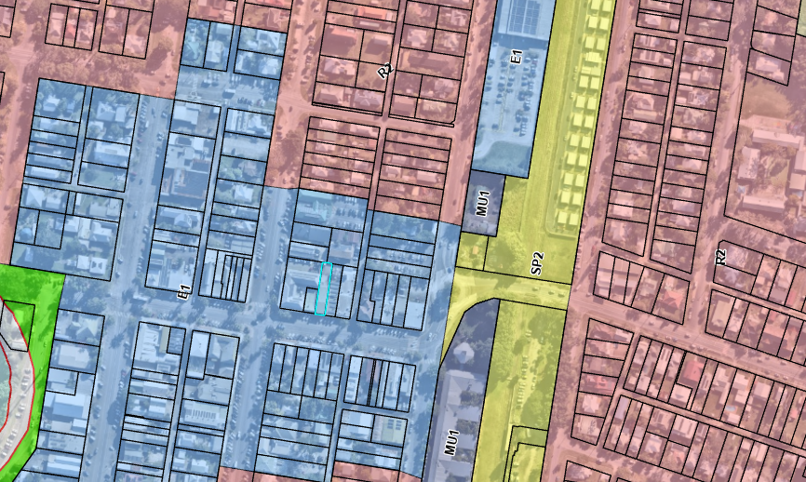

The current use of the development site (a public car park and lavatory) services the township, providing facilities within 50m of Burringbar Street. The land is within the Mullumbimby Heritage Conservation Area, and Burringbar Street accommodates numerous Heritage Items listed under the Byron LEP 2014, including the National Bank Building which adjoins the site at the immediate south-west. Figure 3 provides a map of items and areas listed in Schedule 5 – Environmental Heritage LEP 2014.

Figure 3 – Heritage Map
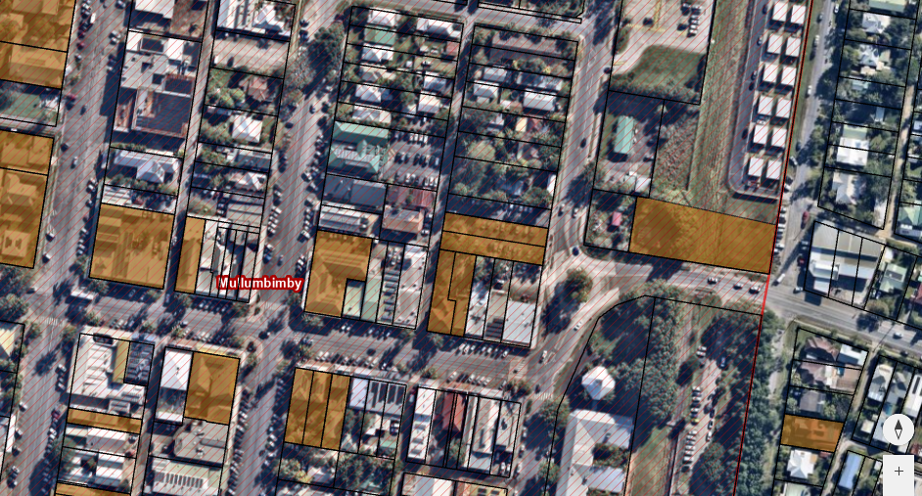

- THE PROPOSAL AND BACKGROUND

  - The Proposal

Development consent is sought for demolition of a heritage listed public toilet building, public carpark (43 spaces) and associated services, removal of 32 native and exotic trees; and construction of affordable housing / mixed used development within a three-storey building. The proposed ground floor comprises a four room boarding house, one commercial premises, associated parking, essential services, pedestrian and vehicular access, bicycle storage, and amenities. The proposed level 1 and 2 incorporate 28 shop top housing apartments, 24 of which are nominated as affordable. Refer to ATTACHMENT C for architectural and civil plans.

The proposed building will have a total GFA of 1,620.5m² and a maximum height, to the ridge line of the roof, of 11.54m. A more detailed description of the proposal follows:

Ground floor
- Retail tenancy (commercial premises), with a GFA of 79.9m². This tenancy has direct frontage to, and pedestrian access from, Station Street. An accessible WC is provided on the ground floor.
- Residential entry and lift lobby with secure access (wheelchair access).
- 19 car parking spaces, including 5 accessible spaces and provision for 4 EV charging stations. Vehicular access will be via McGoughans Lane only.
- 10 designated bicycle parking spaces.
- Bin storage rooms serving both residential and retail areas, along with a designated bin collection area, accessible from McGoughans Lane.
- Services and letterboxes.
- Emergency egress staircases.
- Landscaped areas totalling 518m² (30.6% of site area), with deep soil areas totalling 516m² (30.5% of site area).
- Boarding house with 4 boarding rooms, each with their own kitchen and bathroom facilities, and outdoor terrace, a communal living room, communal outdoor living area, and 292m² of dedicated landscaped area. The boarding house will have its own secure pedestrian access from Station Street and McGoughans Lane, together with access to the secure parking area and bin storage room. The floor area of the boarding rooms ranges from 35m² to 30m².

First floor
- 6 x studio apartments (35m² – 36m²), 6 x one-bedroom apartments (50m² – 58m²), and 2 x two-bedroom apartments (74m² - 75m²), all with balconies.
- Communal gathering area totalling 88m².
- Lift and stair access.

Second floor
- 6 x studio apartments (35m² – 36m²), 6 x one-bedroom apartments (50m² – 58m²), and 2 x two-bedroom apartments (74m² - 75m²), all with balconies.
- Lift and stair access.

The Access Report submitted with the DA, prepared by iAccess Residential, dated 29 May 2026, states that 6 dwellings within the development will need to satisfy Accessible housing requirements of the Apartment Design Guide. The accessible dwellings are not marked on the plans, however, this matter can be conditioned. The Access report nominates 3 dwellings as Adaptable to meet the requirements of DCP 2014 Section B13.22. These dwellings include G01 (boarding house room); 1.06 and 1.14.

Affordable Housing
The four (4) x boarding house rooms are affordable housing in perpetuity and will be managed by a registered community housing provider in accordance with Clause 26 SEPP (Housing) 2021. Twenty-four (24) of the twenty-eight (28) shop top apartments will be used for affordable housing for a minimum of 15 years and will also be managed by a registered community housing provider in accordance with Clause 21 SEPP (Housing) 2021. 2 x 2 bedroom apartments and 2 x 1 bedroom apartments will not be ‘affordable’ pursuant to SEPP (Housing) 2021.

At the time of writing the proponent stated that a community housing provider was chosen for this project, however, they withdrew their interest during DA assessment. A community housing provider will be chosen once funding has been secured from the Housing Affordability Fund. Development data is provided in Table 1 below.

Table 1: Development Data
Control | Proposal
Site area | 1,691m²
GFA | 1,620.5m²
FSR (retail/residential) | LEP 2014 FSR - 0.75:1  SEPP(Housing) 2021, Chapter 1 S12A 30% additional floor space – 0.975:1  Proposed – 0.96:1
Clause 4.6 Requests | Not applicable
No of apartments | 28 shop top apartments  Boarding house with 4 self-contained rooms
Max Height | LEP 2014 HoB – 9m  SEPP(Housing) 2021, Chapter 2 S18 30% additional HoB – 11.7m  Proposed – 11.54m
Landscaped area | Landscaped area 518m² (30.6% of site)  Deep soil landscaping 516m² (30.5% of site)  Site area 1,691m²
Car Parking spaces | SEPP(Housing) 2021  Note. 2 x 2 bedroom apartments and 2 x 1 bedroom apartments will not be ‘affordable’ pursuant to SEPP (Housing) 2021.  SEPP (Housing) 2021  Affordable Housing 24 of the 28 shop top apartments.  Affordable  Clause 22A  1 bed & studios: 21 apartments @ 0.4 spaces/apartment = 8.4 spaces  2 bed: 3 apartments @ 0.5 spaces/apartment = 1.5 spaces  Boarding house rooms: (Cl 24(i)) 4 x boarding house rooms @ 0.5 spaces/rm = 2 spaces  Non-affordable  2 x 1 bed @ 0.5 spaces/apartment = 1.0 spaces  2 x 2 bed @ 1.0 spaces/apartment = 2.0 space  DCP Chapter B4 Traffic Planning, Vehicle Parking, Circulation and Access  Shop - 1 space/20m² GFA. Proposed 77.4m² shop = 4 spaces  Total required – 18.8 spaces  Proposed - 19
Setbacks | North (side) – 3m and 6m  South (side – 3m  West (rear McGoughans Lane) – 3m  East (front Station Street) – Ground floor – 0.630m; with concrete awning overhang into road reserve 0.8m

Refer to Figure 4 for Station Street elevation and Figure 5 for McGoughans Lane perspective.

Figure 4 – Station Street elevation
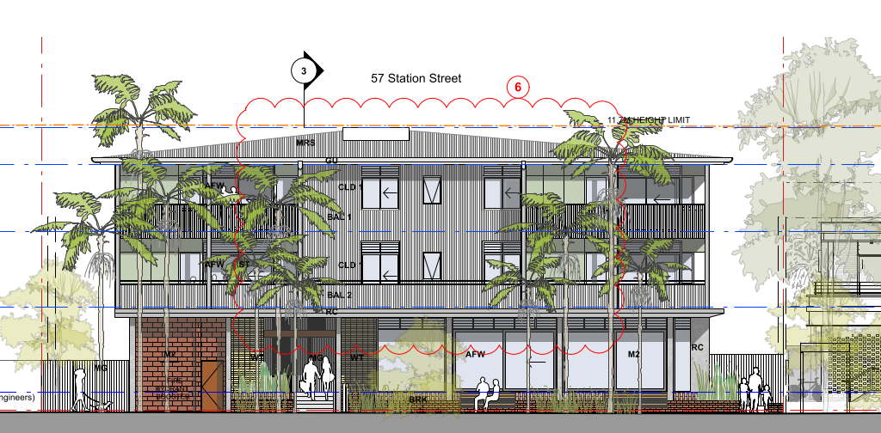

Figure 5 – McGoughans Lane perspective
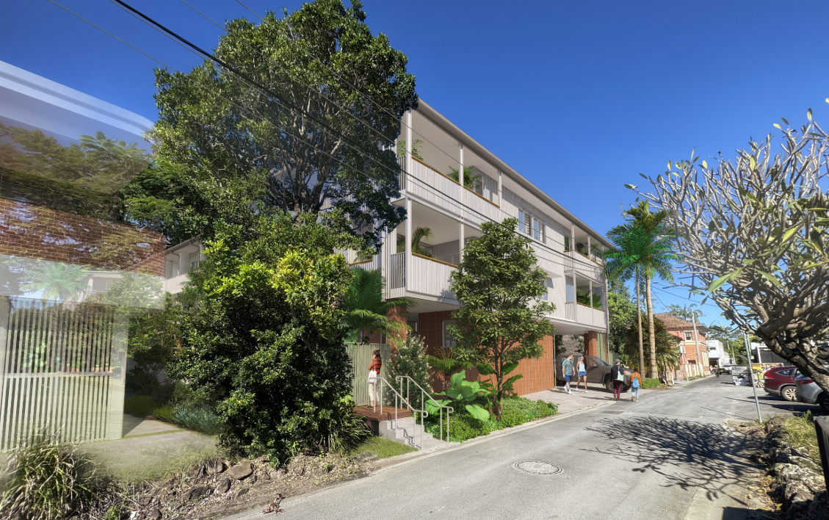

  - Background

A pre-lodgement meeting (22.2024.25.1) was held on Wednesday 27 November 2024 and development advice provided prior to the lodgement of the applicant where various issues were discussed. A summary of the key issues and how they have been addressed by the proposal is outlined below:
Issues | Proposed development response
Activating street frontage of shopfronts | - Ground level shop proposed fronting Station Street which will activate the street frontage.
Removal of heritage item (public lavatory) | - Statement of Heritage Impact prepared by Everick Heritage, dated March 2025 submitted with original DA. Statement of Heritage Impact Addendum prepared by Everick Heritage, dated 29 May 2026 submitted with Amended DA. The reports recommend: no elements of the built fabric are considered appropriate for salvage or reuse; no separate archival photographic record is required. Conditions of consent would resolve the matter.
Heritage conservation (design, scale, materials, roof form, landscaping) | - Scale, roof form, design and landscaping have been modified in the amended DA lodged on 16/06/2026, partially in accordance with Council’s requests. The bulk and scale issue were not addressed, particularly on the eastern façade. The applicant has stated that plans will not be further amended.
Hydraulics | - Civil engineering plans submitted with DA
Waste management | - Waste Management Plan submitted with DA
Access and parking | - Traffic Impact Assessment submitted with DA
Stormwater management | - Civil engineering plans submitted with DA
Flood assessment | - Flood Impact Assessment submitted with DA

The DA was originally lodged on 25/06/2025. An amended DA was lodged on the 16/06/2026. Modifications to the amended DA were submitted on 29/09/2026. A chronology of the development application since lodgement is outlined in Table 2, including the Panel’s involvement (briefings, deferrals etc) with the application:

Table 2: Chronology of the DA
Date | Event
25/6/25 | DA lodged
3/7/25 to 31/8/25 | Exhibition of the DA
27/6/25 | DA referred to external agencies
- RFI 27/6/25  - Meeting Oct 25  - RFI 9/12/25  - RFI 16/1/26  - March & April 26 general correspondence  - Meeting 1/4/26 | Request for Information from Council to applicant; general correspondence and follow up on design, engineering & power line enquiries with applicant; meetings between applicant and Council. Requests to setback upper storey on Station Street.
16/6/26 | Amended DA lodged (Amended DA#1)  - Southern boundary setback increased to 3m to relocate building so that it is no longer over a Council sewer main and potential to provide access to rear of adjacent commercial premises front Burringbar Street.  - Amended roof design.  - Minor consequential changes to floor plan in response to smaller building footprint, including decrease in total number of bedrooms while maintaining total number of 28 shop top apartments and 4 room boarding house. Decrease two shops to one.  - Amended landscaping  - Updated technical reports.
22/6/26 to 16/8/26 | Re-exhibition of the amended DA
23/6/26 | DA re-referred to external agencies
6/7/26 | Site inspection with NRPP
15/7/26 | Applicant requested to amend the plans to setback the upper level on the Station Street side pursuant to Clause 36(1) & (3) of the EP&A Regs 2021. The applicant did not provide amended plans pursuant to Clause 36(5)(a) of the Regs.
9/8/2026 | Independent Architect (Roderick Simpson) engaged by Byron Shire Council to review the bulk and scale issues of non-compliance.
13/8/2026 | Independent Architect submits to Council draft review of design issues and recommendations.
25/9/2026 | Meeting with applicants, key Council staff and consulting planner.
29/09/2026 | Submission of modified plans for the amended DA. (Amended DA#2)

  - Site History

The site is Council-owned Operational Land and currently provides up to forty three (43) public car parking spaces and a public lavatory.

Council’s Authority database has a record of the following historical applications for the site:

Application | Description | Outcome
DA 5.1992.129.1 | Sign | Refused 16/6/1992
DA 10.2025.118.1 | Mixed use development: Demolition of existing public toilet (heritage item), carpark, and associated services, tree removal; and construction of affordable housing comprising shop top housing with two ground floor commercial premises and carparking, 28 apartments above and ground floor boarding house. | Withdrawn 22/4/25

- STATUTORY CONSIDERATIONS

When determining a development application, the consent authority must take into consideration the matters outlined in Section 4.15(1) of the Environmental Planning and Assessment Act 1979 (‘EP&A Act’). These matters as are of relevance to the development application include the following:

- the provisions of any environmental planning instrument, proposed instrument, development control plan, planning agreement and the regulations
(i) any environmental planning instrument, and
(ii) any proposed instrument that is or has been the subject of public consultation under this Act and that has been notified to the consent authority (unless the Planning Secretary has notified the consent authority that the making of the proposed instrument has been deferred indefinitely or has not been approved), and
(iii) any development control plan, and
(iiia) any planning agreement that has been entered into under section 7.4, or any draft planning agreement that a developer has offered to enter into under section 7.4, and
(iv) the regulations (to the extent that they prescribe matters for the purposes of this paragraph),
that apply to the land to which the development application relates,
- the likely impacts of that development, including environmental impacts on both the natural and built environments, and social and economic impacts in the locality,
- the suitability of the site for the development,
- any submissions made in accordance with this Act or the regulations,
- the public interest.

These matters are further considered below.

It is noted (and considered further in this report) that the proposal is:
- Crown DA – The consent authority cannot refuse the consent, except with the approval of the Minister pursuant to Section 4.33(1)(a) of the EP&A Act 1979. Written agreement from the applicant or the Minister to the proposed conditions of consent must be provided pursuant to Section 4.33(1)(b) of the EP&A Act 1979.

  - Relevant Acts and other provisions of the EP&A Act 1979, Environmental Planning Instruments, proposed instrument, development control plan, planning agreement and the regulations

The relevant environmental planning instruments, proposed instruments, development control plans, planning agreements and the matters for consideration under the Regulation are considered below.
- Relevant Acts and other provisions of the EP&A Act 1979
- Biodiversity Conservation Act 2016 and Biodiversity Conservation Regulation
Pursuant to Part 3, the site is not incorporated in the Biodiversity Values Map.
Pursuant to Part 4, there are no threatened species or threatened ecological communities present on the site. Council’s consulting ecologist did not raise any concerns.
Pursuant to Part 6, the proposal includes the removal of native and non-native vegetation. The minimum lot size applying to the land is 200m² (below the 1ha threshold). The Biodiversity Offset Scheme clearing threshold is 0.25ha. Approximately 200m² of vegetation clearing (native and non-native spp) is proposed, significantly less than 0.25ha. The Biodiversity Offset Scheme is not triggered.

- EP&A Act 1979, Division 4.6 Crown Development
Landcom (the developer) is a public authority, being a Statutory State Owned Corporation under the State Owned Corporations Act 1989, and as such, the development is Crown Development.
Pursuant to Section 4.33(1) of the EP&A Act 1979, the development application cannot be refused except with the approval of the Minister. Further, a consent condition cannot be imposed without the approval of the applicant or the Minister.

- EP&A Act 1979, Section 4.46 Integrated Development
Not applicable.

- Section 4.15(1)(a)(i) - Provisions of Environmental Planning Instruments

The following Environmental Planning Instruments are relevant to this application:

- State Environmental Planning Policy (Housing) 2021
- State Environmental Planning (Biodiversity and Conservation) 2021
- State Environmental Planning Policy (Planning Systems) 2021
- State Environmental Planning Policy (Resilience and Hazards) 2021
- State Environmental Planning Policy Sustainable Buildings) 2022
- Byron Local Environmental Plan 2014;

A summary of the key matters for consideration arising from these State Environmental Planning Policies are outlined in Table 3 and considered in more detail below.

Table 3: Summary of Applicable Environmental Planning Instruments and Planning Controls
EPI | Matters for Consideration | Comply (Y/N)
SEPP (Housing) 2021 | Chapter 1 Preliminary  Section 3 Principles of Policy  The proposal is consistent with policy principles.  Section 7 Land to which this policy applies  This policy applies to the entire State  Section 8 Relationship with other environmental planning instruments  This policy prevails to the extent of any inconsistency with another EPI  Section12A Limitation on additional floor space ratio  FSR under LEP 2014 0.75:1. 30% bonus applies under this SEPP which equates to 0.975:1 FSR. Proposed FSR 0.957:1  Chapter 2: Affordable Housing  Division 1 In-fill affordable housing  28 shop top housing apartments, 24 of which are proposed ‘affordable housing’  Division 2 Boarding houses  4 x boarding house rooms – affordable housing  Complies  Chapter 4 Design of residential apartment development  This chapter applies to 28 shop top housing apartments.  Schedule 9 Design principles for residential apartment development – applicable  Apartment Design Guide (ADG) – applicable  Design review panel – not applicable  Complies  Schedule 9 Design principles for residential apartment development | Y  Y  Y  Y
SEPP (Biodiversity and Conservation) 2021 | Chapter 2 Vegetation in non-rural areas  Section 2.3 Land to which this Chapter applies  2.3(1)(b) The subject land is within Zone E1 Local Centre and this Chapter applies.  Section 2.6 Clearing that requires permit or approval  Approval is required for removal of vegetation on the site. Council’s consulting ecologist raises no concerns. Landscaping proposed. Clearing does not exceed biodiversity offset threshold. | Y
Apartment Design Guide (ADG) | Part 3 Siting the development  Part 4 Building design | Y
SEPP (Planning Systems) 2021 | Chapter 2: State and Regional Development  Section 2.19(1) declares the proposal regionally significant development pursuant to Clause 4 of Schedule 6.  Chapter 4: Concurrences and consultations  - Section 4.31(1)(f)(iii) Referral to Essential Energy – the proposal is satisfactory subject to conditions.  Undergrounding of powerlines in Station Street proposed. Proponent dealing with Essential Energy. | Y
SEPP (Resilience & Hazards) 2021 | Chapter 2: Coastal Management  - Section 2.10(1) & (2) – Development on land within the coastal environment area  - Section 2.12 – Development in coastal zone generally —development not to increase risk of coastal hazards.  Chapter 4: Remediation of Land  Section 4.6 – Contamination and remediation has been considered in the Contamination Report and the proposal is satisfactory subject to conditions. | Y  Y
SEPP (Sustainable Buildings) 2022 | BASIX Certificate applies. | Y
Proposed Instruments | No proposed instruments relevant to the subject site. | N/A
Byron LEP 2014 | - Clause 1.2 – Aims of Plan  - Clause 2.3 – Permissibility and zone objectives  - Clause 2.7 – Demolition requires development consent  - Clause 4.3 – Height of Buildings (overridden by Housing SEPP)  - Clause 4.4 – Floor Space Ratio (overridden by Housing SEPP)  - Clause 5.10 – Heritage Conservation  - Clause 5.21 – Flood Planning  - Clause 5.22 – Special flood considerations  - Clause 6.1 – Acid sulfate soils  - Clause 6.2 – Earthworks  - Clause 6.6 – Essential Services  - Clause 6.17 – Affordable housing in employment, mixed use and residential zones. | Y
Byron DCP 2014 | - Part A – Preliminary  - Chapter B1 – Biodiversity  - Chapter B3 – Services  - Chapter B4 – Traffic planning, vehicle parking, circulation and access  - Chapter B5 – Providing for cycling  - Chapter B8 – Waste minimisation and management  - Chapter B9 – Landscaping  - Chapter B11 – Planning for crime prevention  - Chapter B12 – Social Impact Assessment  - Chapter B13 – Access and mobility  - Chapter B14 – Excavation and fill  - Chapter C1 – Non-indigenous heritage  - Chapter C2 – Areas affected by flood  - Chapter D1 – Residential accommodation in urban, village and special purpose zones  - Chapter D4 – Commercial and retail development  - Chapter E3 – Mullumbimby | Y

Tables 4 and 5 below provide an assessment against the requirements for SEPP (Housing) 2021.
Table 4 – SEPP (Housing) 2021 – Chapters 1,2 & 4 - Compliance Table
Criteria | Assessment comments
Chapter 1 Preliminary
3 Principles of Policy  - Enable housing diversity  - Encourage housing for vulnerable members of the community  - Housing with reasonable amenity  - Make good use of planned infrastructure and services  - Minimise adverse climate and environmental impacts  - Housing to reflect and enhance locality  - Provide short term rental accommodation while managing impacts  - N/A | Complies  - Proposed diverse affordable housing.  - 24 of the 28 shop top apartments and the 4 boarding housing rooms will be dedicated affordable housing operated by a registered community housing provider.  - The proposal is consistent with the Apartment Design Guide (ADG), Housing SEPP, LEP and DCP provisions. Central location, pleasant outlook and high level of amenity.  - The site is within the Mullumbimby Town Centre and is close to all services.  - Central location, WMP, BASIX  - Building articulation with the inclusion of verandas and landscaping with use of various façade materials  - Boarding house rooms residence for at least 3 months with a PoM.
12A Limitation on additional floor space ratio  Additional FSR 30% | Complies  Proposes in-fill affordable housing and a boarding house. This provision applies.  LEP 2014 FSR - 0.75:1  SEPP 30% additional floor space – 0.975:1  Proposed – 0.96:1
Chapter 2 Affordable Housing
Division 1 In-fill affordable housing
15A Objective of division  Deliver new infill affordable housing | Complies  24 of the 28 shop top apartments - infill affordable housing  4 room boarding house
15C Development to which this division applies  - Development permissible in the zone  - Minimum 10% affordable component | Complies  Shop top housing and boarding house permissible with consent in Zone E1.  The proposal significant exceeds the minimum affordable 10% component
16 Affordable housing requirements for additional FSR  FSR – 30% additional  Height of Buildings – 30% additional | Complies  FSR  LEP 2014 FSR - 0.75:1  SEPP 30% additional floor space – 0.975:1  Proposed – 0.96:1  HoB  LEP 2014 HoB – 9m  SEPP(Housing) 2021, 30% additional HoB – 11.7m  Proposed – 11.54m
17 Additional floor space ratio for relevant authorities and registered community housing providers | Section 12A applies
18 Affordable housing requirements for additional building height | Section 16 applies
19 Non-discretionary development standards – the Act s 4.15  Note. See the Act s 4.15(3) which does not prevent development consent being granted if a non-discretionary development standard is not complied with.  (2) Non-discretionary development standards  (a) minimum site area 450m²,  (b) a minimum landscaped area - the lesser of:  (i) 35m² per dwelling, or  (ii) 30% of the site area,  (c) a deep soil zone on at least 15% of the site area, where—  (i) deep soil zones minimum dimensions of 3m, and  (ii) if practicable, at least 65% of the deep soil zone is located at the rear of the site,  (d) living rooms and private open spaces in at least 70% of the dwellings receive at least 3 hours of direct solar access between 9am and 3pm at mid-winter,  (e), (f) (Repealed)  (g) the minimum internal area, if any, specified in the Apartment Design Guide for the type of residential development,  (h) N/A as (g) applies therefore (i) not applicable  (3) Subsection (2)(c) and (d) do not apply to development to which Chapter 4 applies. | Complies  (2)  (a) Site area 1,691m²  (b) Based on 35m² per dwelling x 32, 1,120m² is required. Based on 30% of site area, 507.3m² is required, so this applies as the lesser. Total landscaped area proposed is 518m² or 30.6% of site area.  (c) Not applicable as per subsection 3.  (d) Not applicable as per subsection 3.  (g) All 28 shop top housing apartments comply with ADG  (3) Chapter 4 applies to this development
20 Design requirements  (3) Consent authority must consider the design of the residential development is compatible with:  (a) desirable elements of local area character; or  (b) for precincts undergoing transition – desired future character | Complies  The original DA and Amended DA #1 were inconsistent with the built form and character of the Mullumbimby Heritage Conservation Area.  Amended DA #2 included modification to the Station Street façade of the building, as well as landscaping and pavement works within the Station Street road reserve. The amended façade treatment includes: removal of part of the second level verandah; and recommended condition regarding use of FC cladding board and soft colours. These modifications are more compatible with the aesthetic character of the Mullumbimby Heritage Conservation Area. The proposed landscaping and pavement works will enhance the following: public domain with the provision of shade and shelter; streetscape appeal, especially considering the prominent location of the site; privacy for future residents of the development; microclimate with the provision of morning dappled shade for future residents and associated decrease in energy consumption; and urban biodiversity.
21 Must be used as affordable housing for a least 15 years  - The development will be affordable housing for a least 15 years  - The affordable housing component will be managed by a registered community housing provider | Complies  Conditions of consent
22 Subdivision permitted with consent | Noted
22A Requirement to provide carparking  Development consent must not be granted to development under this division unless—  (a) the consent authority is satisfied the development will result in—  (i) the following number of parking spaces for dwellings used for affordable housing—  (A) for each dwelling containing 1 bedroom—at least 0.4 parking spaces,  (B) for each dwelling containing 2 bedrooms—at least 0.5 parking spaces,  (C) for each dwelling containing at least 3 bedrooms— at least 1 parking space, and  (ii) the following number of parking spaces for dwellings not used for affordable housing—  (A) for each dwelling containing 1 bedroom—at least 0.5 parking spaces,  (B) for each dwelling containing 2 bedrooms—at least 1 parking space,  (C) for each dwelling containing at least 3 bedrooms—at least 1.5 parking spaces, or  (b) the consent authority has considered the Guide to Transport Impact Assessment published by Transport for NSW on 4 November 2024. | Complies  SEPP(Housing) 2021  Note. 2 x 2 bedroom apartments and 2 x 1 bedroom apartments will not be ‘affordable’ pursuant to SEPP (Housing) 2021.  SEPP (Housing) 2021  Affordable Housing 24 of the 28 shop top apartments.  Affordable  Clause 22A  1 bed & studios: 21 apartments @ 0.4 spaces/apartment = 8.4 spaces  2 bed: 3 apartments @ 0.5 spaces/apartment = 1.5 spaces  Boarding house rooms: (Cl 24(i)) 4 x boarding house rooms @ 0.5 spaces/rm = 2 spaces  Non-affordable  2 x 1 bed @ 0.5 spaces/apartment = 1.0 spaces  2 x 2 bed @ 1.0 spaces/apartment = 2.0 space  DCP Chapter B4 Traffic Planning, Vehicle Parking, Circulation and Access  Shop - 1 space/20m² GFA. Proposed 77.4m² shop = 4 spaces  Total required – 18.8 spaces  Proposed - 19
Chapter 2 Affordable Housing
Division 2 Boarding houses
23 Boarding houses permitted with consent | Complies  Boarding houses are permitted with consent in Zone E1 BLEP 2014.
24 Non-discretionary development standards-the Act, s 4.15  (1) The object - prevent the consent authority from requiring more onerous standards for the matters.  Note—  See the Act, section 4.15(3), which does not prevent development consent being granted if a non-discretionary development standard is not complied with.  (2) Non-discretionary development standards:  (a) additional 30% FSR for boarding house,  (b) N/A  (c) N/A  (d) N/A  (e) at least 3 hours of direct solar access provided between 9am and 3pm at mid-winter in at least 1 communal living area,  (f) N/A  (g) N/A  (h) communal open spaces— at least 20% of the site area, and each with min dimensions of 3m,  (i) 0.5 parking spaces for each boarding room,  (j) N/A. | Generally Complies  (a) Both in-fill affordable housing and a boarding house are proposed and S12A limits FSR to 130% of BLEP 2014 FSR standard. Proposed GFA – 1,691m²; site area 1,691m²; proposed FSR 0.96:1; FSR limit 0.975:1.  (e) Communal living area receives a min of 3hrs solar access in mid-winter with existing northern building stock on adjacent northern allotment (55 Station Street Mullumbimby). If double storey with some upper-level mezzanine approved under DA 10.2025.243.1 is constructed 3hrs solar access in boarding house common area will unlikely be achieved, however, each individual board house room will likely achieve in excess of 2 hrs solar access mid-winter.  (h) At least 20% of site area is communal open space with min 3m dimension  (i) 0.5 parking spaces provided for each boarding house room
25 Standards for boarding houses  (1) Development consent must not be granted under this Division unless the consent authority is satisfied that—  (a) GFA of boarding house room, excluding an area, if any, used for the purposes of private kitchen or bathroom facilities, no greater than 25m², and  (b) Maximum 2 adult residents per boarding house room, and  (c) adequate bathroom, kitchen and laundry facilities within the boarding house  (d) N/A  (e) for a boarding house on land in a business zone—no part of the ground floor of the boarding house that fronts a street will be used for residential purposes  (f) N/A  (g) the minimum lot size 800m².  (h) each boarding room has a floor area, excluding an area, if any, used for the purposes of private kitchen or bathroom facilities, of at least the following—  (i) N/A  (ii) Min GFA, excluding private kitchen & bathroom - 16m², and  (i) adequate bicycle and motorcycle parking spaces.  (2) Development consent must not be granted under this Division unless the consent authority considers whether—  (a) the design of the boarding house will be compatible with—  (i) the desirable elements of the character of the local area, or  (ii) for precincts undergoing transition—the desired future character of the precinct, and  b) the front, side and rear setbacks for the boarding house are not less than—  (i) N/A  (ii) N/A  (c) 3 storeys - comply with the minimum building separation distances specified ADG | Complies  (1)  (a) G01 – 23m²; G02 – 22m²; G03 – 24m²; & G04 – 21m²  (b) No boarding house room will accommodate more than two adults  (c) Each boarding room is provided with bathroom, kitchen and laundry facilities  (e) The site is zoned E1, a business zone. No part of the boarding house fronts the street.  (g) Site area 1,691m²  (h) Each boarding room has an area exceeding 16m² excluding kitchen and bathroom areas (refer to (a))  (i) 10 bicycle parking spaces proposed, 4 of which can be used by boarding room residents.  (2)  (a) See comments for character in Section 20(3) of this table  (c) ADG separation distances have been applies to the 3-storey building.
26 Must be used for affordable housing in perpetuity  (1) Development consent must not be granted under this Division unless the consent authority is satisfied that from the date of the issue of the occupation certificate and continuing in perpetuity—  (a) the boarding house used for affordable housing, and  (b) the boarding house will be managed by a registered community housing provider.  (2) N/A | Complies  Condition of consent
27 Subdivision of boarding houses not permitted | Complies  No subdivision proposed
Chapter 4 Design of residential apartment development
144 Application of chapter  (2) This chapter applies to -  (a) N/A,  (b) shop top housing,  (c) N/A  (3) This chapter applies to development only if—  (a) the development consists of—  (i) the erection of a new building, or  (ii) N/A  (iii) N/A, and  (b) the building is at least 3 storeys, not including underground car parking storeys, and  (c) N/A. | Chapter applies  The proposed development involves shop top housing; is 3 storeys and does not include underground car parking.  Boarding houses are not residential apartment development in accordance with S144(2) of the Housing SEPP and the proposed ground floor boarding house rooms are not subject to assessment under Chapter 4 or Schedule 9 of the Housing SEPP and nor is the boarding house subject to assessment under the ADG.
145 Referral to design review panel for development applications | N/A  A design review panel has not been constituted for the LGA
147 Determination of development applications and modification applications for residential apartment development  (1) Development consent not to be granted until consent authority considers—  (a) design principles for residential apartment development set out in Schedule 9,  (b) the Apartment Design Guide,  (c) N/A  (2) N/A  (3) To avoid doubt, subsection (1)(b) does not require a consent authority to require compliance with design criteria specified in the Apartment Design Guide.  (4) N/A | Complies  Consistent with Schedule 9 and the ADG. Refer to relevant table below.
148 Non-discretionary development standards for residential apartment development—the Act, s 4.15  (1) The object - consent authority cannot require more onerous standards, if complied with, for the matters.  Note—  See the Act, section 4.15(3), which does not prevent development consent being granted if a non-discretionary development standard is not complied with.  (2) The following are non-discretionary development standards—  (a) the car parking equal to, or greater than, the recommended minimum car parking in Part 3J of the ADG,  (b) GFA each apartment equal to, or greater than, the recommended minimum GFA for the apartment type in Part 4D of the ADG,  (c) the ceiling heights equal to, or greater than, the recommended minimum ceiling heights in Part 4C of the ADG. | Complies  (a) Refer to car parking comments for Section 22A in this table  (b) & (c) Refer to Schedule 9 Design Principles in this table and ADG assessment comments
149 Apartment Design Guide prevails over development control plans  (1) A requirement, standard or control for residential apartment development that is specified in a development control plan and relates to the following matters has no effect if the Apartment Design Guide also specifies a requirement, standard or control in relation to the same matter—  (a) visual privacy,  (b) solar and daylight access,  (c) common circulation and spaces,  (d) apartment size and layout,  (e) ceiling heights,  (f) private open space and balconies,  (g) natural ventilation,  (h) storage.  (2) This section applies regardless of when the development control plan was made. | Noted  Non-applicable controls from Byron DCP are noted in DCP compliance table.

The SEPP (Housing) 2021 Schedule 9 Design principles for residential apartment development compliance table is provided in Table 5.
Note. Boarding houses are not residential apartment development in accordance with S144(2) of the Housing SEPP and the proposed boarding house rooms are not subject to assessment under Chapter 4 or Schedule 9 of the Housing SEPP and nor is the boarding house subject to assessment under the ADG.
Table 5 – SEPP (Housing) 2021 - Schedule 9 Design principles
Design principle | Assessment of design response
Principle 1: Context and Neighbourhood Character | Complies  The 1691m² allotment is located within the Mullumbimby CBD with Zone E1 Local Centre. The site provides high level access to surrounding retail, health, education, recreation, community and religious facilities.  Mullumbimby’s grid pattern street network and generally level topography provides a good level of walkability to the aforementioned facilities, many of which are located within 400 – 800m or a 5 to 10 minute walk. The Brunswick River is located within walking distance to the north and west of the site and is flanked by Riverine parkland, providing ideal locations for passive and active recreation.  Mullumbimby is subject to low level flooding and ground level commercial and residential development is located above the flood planning level.  The subject allotment is within the Mullumbimby Heritage Conservation Area. A number of heritage buildings are proximal to the site including, but not limited to banks, hotels, churches and dwellings. The subject site is a Council owned car park with 43 parking spaces and includes a heritage listed public lavatory designed by local architect Christine Vadasz. Both the car park and lavatory are proposed for demolition.  The Byron Shire Council Delivery Program 2025 – 2029 Section 4.2 Priorities include:  4.2.1 – Seek opportunities that provide fair appropriate, and affordable housing  4.2.2 – Investigate partnerships and pilots that deliver an innovative and affordable housing model  Byron Council have partnered with Landcom to propose the affordable housing development on the site, in accordance with the Delivery Program. Council seeks to facilitate the delivery of more affordable housing for, inter alia, attraction and retention of key workers.  The proposed development utilises additional building height and floor space ratio in accordance with SEPP (Housing) 2021. Surrounding development consists of a mix of double and single storey commercial and residential buildings.  The site has an eastern frontage to Station Street on the eastern edge of the commercial area. It is a visually prominent site when approaching Mullumbimby CBD from the east along the main entrance, Argyle Street. The site has western frontage to McGoughans Lane. The southern boundary adjoins commercial allotments with a frontage to Burringbar Street. Some of these businesses have utilised informal access to the rear of their establishments from the subject Council owned car park. Conditions of consent can formalise the access within an easement. The adjoining northern allotment was subject to the issuance of development consent in November 2025 for mixed-use development comprising ground floor commercial premises, car parking and eight shop top housing units.  The Station Street frontage is the principal entry for the commercial component of the proposal. The first and second level shop top housing apartments present to Station Street with eastern verandahs, and an appropriate combination of cladding materials and a symmetrical hipped roof form that acknowledges similar roof forms on surrounding smaller scaled buildings.  Amended DA #2 included modification to the Station Street façade of the building, as well as landscaping and pavement works within the Station Street road reserve. The amended façade treatment is more compatible with the aesthetic character of the Mullumbimby Heritage Conservation Area. The proposed Station Street landscaping and pavement works will positively impact the streetscape appeal of the proposed development especially considering the prominent location of the site. Additionally, landscaping will enhance the following: public domain with the provision of shade and shelter; privacy for future residents of the development; microclimate with the provision of morning dappled shade for future residents and associated decrease in energy consumption; and urban biodiversity.
Principle 2: Built Form and Scale | Complies  The proposed building siting is similar to other buildings in the town centre in that the commercial component fronts and addresses the street boundary and it includes appropriate side and rear setbacks. The proposal encourages street activation while the side and rear setbacks provide for deep soil landscaping and entry courtyards. Landscaping within the Station Street road reserve is also proposed. The extensive landscaping provides a green vegetative outlook and breaks up the façade of the building.  A covered, open sided car park is located to the rear of the eastern commercial component and northern boarding house rooms. The boarding house rooms open onto landscaped entry courtyards and also include a common room. Resident pedestrian entry to the boarding house is provided from either Station Street of McGoughans Lane.  The two upper floors include 28 shop top housing apartments served by a lift and two stairways. There are six compact apartments at either end of each floor and six north facing studio apartment on each floor accessed off southern balconies. The multiple stairs and open circulation will provide a high level of cross ventilation.  The car park is accessed from the rear McGoughans Lane compared with access and egress from the existing public car park from Station Street and egress from McGougans Lane. The driveway is integrated into the building footprint which deceases its presence and impact and allows the site’s perimeter to be fully landscaped.  The amended DA #2 Station Street façade treatment is more compatible with the aesthetic character of the Mullumbimby Heritage Conservation Area, and the proposed landscaping and footpath works will enhance the Station Street public domain.
Principle 3: Density | Complies  The proposed density, utilising the 30% additional FSR in accordance with SEPP (Housing) 2021, is 0.96:1. The limit under the SEPP is 0.0975:1. This is appropriate for this central location, and the proposal will provide a high level of residential amenity. The site provides for a short walk to retail, education, health, recreation and religious facilities.  The proposed development is consistent with The Byron Shire Council Delivery Program 2025 – 2029 Section 4.2. The proposed architecturally designed development includes 28 shop top housing apartments (4 x 2 bedroom; 12 x 1 bedroom; & 12 x studio apartments); a ground level boarding house comprising 4 boarding rooms; ground floor commercial, carparking and landscaping.  All apartment sizes exceed ADG controls; and incorporate balconies or terraces providing for a good residential amenity, weather protection and ventilation.  The proposal incorporates appropriate setbacks and extensive landscaping and is not considered to be an overdevelopment of this CBD site.
Principle 4: Sustainability | Complies  A BASIX certificate confirms the development will meet the NSW Government’s requirements for sustainable design.  The substantial majority of apartments received solar access to living areas and their various balconies and terraces. Balconies, wide eaves and window hoods are incorporated into the design.  Setbacks and landscaping provide high levels of residential amenity and privacy.  23 of the 28 shop top housing apartments exceed 3 hours mid-winter solar access, in excess of the 70% ADG requirement. There are no single orientation south dwellings.  All primary private open spaces open directly off living rooms and offer protection from direct sun to interiors in summer. 100% of the 28 shop top housing apartments have excellent cross ventilation, well in excess of the 60% ADG requirement.
Principle 5: Landscape | Complies  The site is currently an asphalt car park with some perimeter trees and shrubs. The proposal substantially increases the amount of deep soil planting. The proposal involves 30% deep soil planting, exceeding the 7% required by the ADG. Landscaping is proposed within the southern, western and northern setbacks and the eastern road reserve. The DA is supported with an Aboricultural report that identifies some trees for retention; it is also supported by a Landscape Design Intent. Communal landscaped ground floor area totals 507.3m². The proposed landscaping will enhance residential amenity; and provide privacy, shelter, habitat and shade. It will also enhance the street appeal of the building.
Principle 6: Amenity | Complies  All 28 of the shop top housing apartments will have corner or cross flow ventilation. The combination of landscaping, window design, orientation and solar controls will maximise cooling in the summer and heating in the winter. The floor plan minimises corridor space and maximises habitable areas that open to outdoor areas.  The proposal includes large areas of communal gardens that facilitate circulation for the residents. There are two sets of stairs and a lift that provide good access to voids and galleries, sheltered from the elements while being open to light and air.  All apartments have a balcony directly off the living area that provides for a pleasant outlook. Internal floor area and balconies conform to ADG requirements.  All balconies are inset rather than projecting making them more useful for longer periods of the day and year. Ceiling heights, at 2.7m, conform with ADG requirements. Garbage rooms are conveniently located at grade, with direct access to the rear lane.  The apartments have adequate, ADG compliant, built in storage. All apartments will have lift access and levelled outdoor living areas to internal spaces to facilitate ease of access for all age groups and degrees of mobility. The proposed development complies with BDCP 2014 Chapter B13: Access and Mobility.
Principle 7: Safety | Complies  Safety and security to both the street and within the site would be provided by passive surveillance from all of the apartments as well as from the street. The site perimeter is secure and with the uses of fencing and landscaping. The car park is within gated fenced secure area.  Access points are well defined and will be legible for residents, visitors, and pedestrians.
Principle 8: Housing Diversity and Social Interaction | Complies  The proposed development incorporates a mix of studio, one-bedroom and two-bedroom apartments. 24 of the proposed 28 shop top housing apartments are affordable which would increase housing diversity and social inclusion.  The Access Assessment Report submitted with the DA, prepared by IAccess Residential, dated 29 May 2026 states that the proposal will include six accessible dwellings and three adaptable dwellings.  The main entry, open foyers, a lift, site facilities, terraces, communal gardens, first floor communal terrace, circulation areas, stairs, landings and pleasant outlook provide appropriate communal spaces for a broad range of people. There are good opportunities for social interaction among residents.
Principle 9: Aesthetics | Complies  The proportions and composition of elements of the building are appropriate for the internal layout and structure.  The building incorporates a variety of materials, colours and textures.  A considered combination of landings, terraces, balconies, ventilation, solar access, landscaping and community spaces provide ideal amenity for future residents.  The amended DA #2 Station Street façade treatment is more compatible with the aesthetic character of the Mullumbimby Heritage Conservation Area, and the proposed landscaping and footpath works will enhance the Station Street public domain.

SEPP (Housing) 2021 also requires consideration of the Apartment Design Guide (ADG) which supports the associated design quality principles by giving greater detail as to how those principles might be achieved. The ADG assessment is provided at Attachment B.

Table 6 below provides a compliance table for the remainder of the applicable SEPP’s.
Table 6 – SEPP 2021 Compliance Table
Criteria | Assessment comments
SEPP (Biodiversity and Conservation) 2021
Chapter 2 Vegetation in non-rural areas
Section 2.3 Land to which this Chapter applies  2.3(1)(b) Provides a list of land zones within which the chapter applies | Noted  The subject land is within Zone E1 Local Centre and this Chapter applies.
Section 2.6 Clearing that requires permit or approval | Complies  Approval is required for removal of vegetation on the site. Council’s consulting ecologist raises no concerns. Landscaping proposed. Clearing does not exceed biodiversity offset threshold.
Chapter 4 Koala Habitat Protection
Section 4.8 Development assessment process – approved koala plan of management land. | The subject land is within the Byron Coast Koala Comprehensive Plan of Management “Koala Planning Area”.  The Byron Coast CKPoM does not apply for the following reasons:  - There is no mapped koala habitat on the site or within adjoining or nearby land;  - The land area is 1,691m², significantly under the 1ha threshold.
SEPP (Planning Systems) 2021
Chapter 2 State and regional development
Part 2.4 Regionally significant development | Applies  The proposed development is regionally significant development as it has an estimated development cost of more than $5M, is being carried out on Byron Shire Council owned land by the Crown (Landcom is a public authority, being a Statutory State Owned Corporation under the State Owned Corporation Act 1989. The Northern Regional Planning Panel is the consent authority.
Chapter 4 Concurrences and consultations
Section 4.31 Electricity Infrastructure  Written notice of the development is required to electricity authority if proposal is within 5m of overhead electricity power lines. | Complies  The proposal involves some undergrounding of power lines in Station Street and additional works on powerlines both in Station Street and McGoughans Lane in accordance with the powerlines concept plan submitted with the DA.  Written notice of the development provided to Essential Energy as the proposal is within 5m of overhead electricity power lines.  Essential Energy did not object to the proposal and provided general requirements subject to the relocation / replacement of overhead conductors on the eastern and western sides of the proposed development as outlined in the powerlines concept plan submitted with the DA.  The proponents ASP3 Design Engineer (Accredited Service Provider Level 3) is proceeding with a Design Information Application whereby Essential Energy will issue a design information package that defines the required network works. This will then be incorporated into the final design at the Crown Certificate stage.
SEPP (Resilience and Hazards) 2021
Chapter 2 Coastal management
Section 2.10 Development on land within the coastal environment area  2.10(1) Development consent must not be granted unless consent authority considers whether the development will cause an adverse effect on the following:  (a) the integrity and resilience of the biophysical, hydrological and ecological environment,  (b) coastal environmental values and natural coastal processes,  (c) the water quality of the marine estate  (d) marine vegetation, native vegetation and fauna and their habitats, undeveloped headlands and rock platforms,  (e) existing public open space and safe access to and along the foreshore, beach, headland or rock platform for members of the public, including persons with a disability,  (f) Aboriginal cultural heritage, practices and places,  (g) the use of the surf zone. | Complies  The development site is on the fringe of the 500m buffer area from the Brunswick River, which at its closet point is located approximately 480m to the west.  The proposed development is unlikely to have an adverse impact on the coastal environment listed in Section 2.10(1).
Section 2.12 Development in coastal zone generally-development not to increase risk of coastal hazards  Development consent must not be granted to development on land within the coastal zone unless the consent authority is satisfied that the proposed development is not likely to cause increased risk of coastal hazards on that land or other land. | Complies  The proposed development is not likely to cause increased risk of coastal hazards on that land or other land.
Chapter 4 Remediation of land
Section 4.6 Contamination and remediation to be considered in determining development application  Consent authority to consider whether the land is contaminated. | Complies  The Preliminary Site Investigation (PSI) concluded that “based on the results of the PSI, the site is considered suitable for the proposed residential land use”. Council’s Environmental Health Officer reviewed the PSI and agreed with this conclusion.
SEPP (Sustainable Buildings) 2022
Chapter 2 Standards for residential development-BASIX
Section 2.1 Standards for BASIX development and BASIX optional development | Complies  Amended BASIX Certificate issued for amended proposal. Certificate number: 1788945M_03.
Chapter 3 Standards for non-residential development
Section 3.1 Application of Chapter | Not applicable  The non-residential component of the development (1 shop) is below the threshold value of $5M, therefore Section 3.1 is not applicable.

Byron Local Environmental Plan 2014

The relevant local environmental plan applying to the site is the Byron Local Environmental Plan 2014. The abbreviated aims of the LEP include:

1.2 Aims of Plan
(2) Aims—
(aa) to protect and promote the use and development of land for arts and cultural activity,
(a) to progressively respond to changes in the natural, social and economic environment in a way that is consistent with the following principles of ecologically sustainable development—
(i) the precautionary principle,
(ii) the principle of intergenerational equity,
(iii) the principle of conserving biological diversity and ecological integrity,
(iv) the principle of improving the valuation and pricing of social and ecological resources,
(v) the principle of eliminating or reducing to harmless levels any discharge into the air, water or land,
(vi) the principle of encouraging a strong, growing and diversified economy,
(vii) the principle of providing credible information in open and accountable processes,
(b) to integrate local planning provisions with applicable regional and State planning controls and policies,
(c) to provide a framework for land use management in Byron,
(d) to promote and coordinate the orderly and economic use and development of land,
(e) to build and sustain community resilience by encouraging a diversity of housing choice and affordable housing in appropriate localities,
(f) to encourage development that contributes to a vibrant, socially-diverse community,
(g) to encourage development that contributes to a strong, growing and diversified economy,
(h) to ensure the timely provision and coordination of community services and facilities,
(i) to protect, manage and restore the natural environment and biodiversity of Byron,
(j) to protect the cultural heritage of Byron, including the conservation of built heritage and Aboriginal heritage,
(k) to provide for public involvement and participation in environmental planning and assessment,
(l) to minimise conflict between land uses within a zone and adjoining zones.

The proposal is consistent with these aims for the following reasons:
- Provision of affordable housing in the CBD builds community resilience.
- The proposal is orderly and economic use and development of the land.
- The development will contribute to the vibrant socially diverse community.
- Contributes to a diversified economy.
- The amended is more compatible with the aesthetic character of the Mullumbimby Heritage Conservation Area.

Zoning and Permissibility (Part 2)

The site is located within the Local Centre (E1) Zone pursuant to Clause 2.2 of the LEP. Refer to the Zone Map below.

The proposed land uses include boarding house, shop and shop top housing (mixed use development) which is a permissible use with consent pursuant to Clause 2.3 – Zone objectives and land use table.

The proposal is consistent with Zone E1 Local Centre objectives for the following reasons:

E1 Zone Objective | Assessment comments
To provide a range of retail, business and community uses that serve the needs of people who live in, work in or visit the area. | Complies  The proposed ground floor commercial premises will add to the range businesses that serve the needs of people in the area.
To encourage investment in local commercial development that generates employment opportunities and economic growth. | Complies  The proposed affordable housing development will increase the residential population in the town centre. The multiplier effect will provide for increase commercial, employment and economic opportunities.
To enable residential development that contributes to a vibrant and active local centre and is consistent with the Council’s strategic planning for residential development in the area. | Complies  The proposed affordable housing development will contribute to the vibrancy and activity of the Local Centre.
To encourage business, retail, community and other non-residential land uses on the ground floor of buildings. | Complies  The proposed development includes a ground floor shop.
To maximise public transport patronage and encourage walking and cycling. | Complies  The proposed residential development in the town centre will facilitate walking and cycling to all the local services provided in the area. The proposal will also increase patronage on local bus services linking local towns and villages.

LEP 2014 General Controls and Development Standards (Part 2, 4, 5 and 6)

The LEP also contains controls relating to development standards, miscellaneous provisions and local provisions. The controls relevant to the proposal are considered in Table 7 below. Note. Height of Buildings and Floor Space Ratio Development Standards are set by SEPP (Housing 2021 and not LEP 2014.

Table 7: Consideration of the LEP Controls
LEP Requirements | Assessment comments
Clause 4.3 Height of buildings – 9m – N/A | Complies  Housing SEPP applies max - 11.7m  Proposed -11.54m
Clause 4.4 FSR – 0.75:1 – N/A | Complies  Housing SEPP applies max - 0.975:1  Proposed - 0.96:1
Clause 5.10 Heritage conservation  Cl 5.10(4)  Consider the effect of the proposed development on the heritage significance of the item or area concerned. | Complies  Heritage listed toilet – Condition  Heritage listed public toilet designed by Byron Bay based architect Christine Vadaz, particularly active in the profession from the 1980’s onward.  After consideration of the Statement of Heritage Impact prepared by Everick Heritage; and the comments from Council’s Heritage Advisor; an appropriate strategy to deal with the proposed demolition is to condition the consent requiring: a) an archival report of the heritage item; and b) the preservation of the roof for reuse in a future small scale civic building such as a gazabo or the like, preferably in Mullumbimby. Council’s asset management staff have been informed of the circumstances and short-term storage is possible while an appropriate reuse is decided upon.  New building in Heritage Conservation Area  The amended DA #2 façade treatment, Station Street landscaping and pavement works are more compatible with the aesthetic character of the Mullumbimby Heritage Conservation Area. The proposed Station Street landscaping and pavement works will positively impact the streetscape appeal of the proposed development especially considering the prominent location of the site providing for a shaded treed footpath area consistent with Burringbar Street and elsewhere in Mullumbimby.  The roof of the development has also been amended with a more symmetrical presentation consistent with surrounding rood lines in the conservation area. Whilst an alternative design with a lower profile to Station Street would be welcome, the building has been carefully designed with the amenity of residents being a major consideration as evidenced with the landscaped area on the northern boundary in the design of the development, providing a leafy landscaped area for residents to enjoy. This trade off in design considerations is acceptable with the deep soil landscaping providing a degree of amenity not normally provided in traditional commercial shop top housing development.  Noting the property is on periphery of the town centre adjoining a non-descript single storey commercial development on the corner of Station and Burringbar Street, and a café/ restaurant to the north which has approval to be demolished and replaced with a two to three storey shop top housing development, it is considered the proposal will not have a detrimental impact on the heritage significance of the Mullumbimby Conservation Area.
Clause 5.21 Flood planning  (3) the consent authority must consider—  (a) the impact of the development climate change flood behaviour  (b) the intended design and scale of buildings resulting from the development,  (c) measures to minimise the risk to life,  (d) the potential to modify, relocate or remove buildings. | Complies  Council’s Development Engineer is satisfied the proposed development is consistent with the requirements of the clause with the floors of the development set at or above the design flood planning levels for this area of Mullumbimby.
Clause 5.22 Special flood considerations  (3) Consent authority to consider—  (a) safe occupation and efficient evacuation of people, and  (b) incorporates appropriate measures to manage risk to life, and  (c) adverse environmental affect in the event of a flood. | Complies  Council’s Development Engineer is satisfied the proposed development is consistent with the requirements of the clause.  A flood evacuation plan is required to be prepared for the residents and is conditioned accordingly.
Clause 6.1 Acid sulfate soils  Class 4 Acid Sulfate Soils.  Development consent is required for works 2m below the natural ground surface, and the proposal involves excavation to 3m depth. | Complies  An ASS investigation was conducted which identified potential acid sulfate soils in various samples below 2m.  An ASS Management Plan has been prepared and is supported by Council’s Environmental Health Officer.
Clause 6.2 Earthworks  3) The consent authority must consider—  (a) the likely disruption of, or any detrimental effect on, drainage patterns and soil stability,  (b) the effect of the development on the likely future use or redevelopment of the land,  (c) the quality of the fill or the soil to be excavated, or both,  (d) amenity of adjoining properties,  (e) the source of any fill material and the destination of any excavated material,  (f) the likelihood of disturbing relics,  (g) adverse impacts on, any waterway, drinking water catchment or environmentally sensitive area,  (h) any appropriate measures proposed to avoid, minimise or mitigate the impacts | Complies  No subterranean levels proposed.  Appropriate conditions of consent recommended to mitigate any potential negative impacts
Clause 6.6 Essential services  The development must be serviced by water, electricity, sewer, stormwater drainage and suitable vehicle access. | Complies  The development has access to all essential services. Council’s Development Engineer is satisfied that appropriate measures can be put in place for stormwater drainage.
Clause 6.17 Affordable housing in employment, mixed use and residential zones  Increase supply of affordable housing  Ensure affordable housing is located close to transport and services  Provide, maintain or retain affordable housing | Complies  The proposed development is consistent with the requirements of this clause.

The proposal is considered to be consistent with LEP 2014.

- Section 4.15 (1)(a)(ii) - Provisions of any Proposed Instruments

There are no proposed instruments which have been the subject of public consultation under the EP&A Act, that are relevant to the proposal.

- Section 4.15(1)(a)(iii) - Provisions of any Development Control Plan

The following Development Control Plan is relevant to this application:

Byron Development Control Plan 2014

Table 8 below provides a compliance table for the relevant DCP provisions.
Note. SEPP (Housing) 2021 overrides DCP requirements in certain matters under Clause 9 & 148 (non-discretionary development standards – landscaped areas, floor areas, car parking & ceiling heights); and Clause 149 (Apartment Design Guide (ADG) prevails for the following: visual privacy, solar and daylight access, common circulation and spaces, apartment size and layout, ceiling heights, private open space and balconies, natural ventilation and storage.

Table 8 – DCP 2014 Compliance Table
DCP Requirements | Assessment comments
Chapter B1 Biodiversity
B1.2.4 Vegetation Management Plans & Biodiversity Conservation Management Plans | Complies  Council’s Consulting Ecologist supported the species selection in the Landscaping Plan. The landscaping will provide adequately for any tree removal.
Chapter B3 Services
B3.2.1 Provision of Services | Complies  The development has access to all essential services. Appropriate conditions of consent can be used.  Council’s Development Engineer is satisfied that appropriate measures can be put in place for stormwater drainage.
B3.2.3 Stormwater Management | Complies  Council’s Development Engineer is satisfied that appropriate measures can be put in place for stormwater drainage.
B3.2.4 Sedimentation and Erosion control Measures | Complies  Appropriate consent conditions can be put in utilised to control sedimentation and erosion.
Chapter B4 Traffic Planning, Vehicle Parking, Circulation and Access
B4.2.1 Traffic Impact | Complies  Vehicular access via McGoughans Lane and pedestrian access via Station Street.  Traffic Impact Assessment prepared by Bitzios Consulting. Council’s Development Engineer concludes that the development traffic will generate a low impact to the existing road network.
B4.2.2 Parking Layout Standards | Complies  19 car parking spaces in total. Council’s Development Engineer concludes that the proposed car parking complies with the relevant Australian Standards, DCP and SEPP (Housing) requirements.
B4.2.3 Vehicle Access and Manoeuvring Area | Complies  Council’s Development Engineer is satisfied that appropriate arrangements have been made for vehicle access and manoeuvring in the proposed development.
B4.2.5 Car Parking Requirements | Complies  19 car parking spaces in total. Car parking for the boarding house and shop top housing comply with SEPP (Hosing) 2021 and DCP requirements. 4 parking spaces provided for shop in accordance with DCP requirements. Council’s Development Engineer concludes that the proposed car parking is satisfactory.
B4.2.8 Bicycle, Motorcycles and Coach Parking | Complies  10 bicycle park spaces provided. Council’s Development Engineer is satisfied that the proposed arrangement for bicycle parking exceed DCP requirements.
B4.2.9 Loading Bays | Complies  Council’s Development Engineer is satisfied that the provision of a single Small Rigid Vehicle (SRV) loading bay off McGoughans Lane satisfies the DCP requirements.
Chapter B8 Waste Minimisation and Management
B8.3.1 Demolition of Buildings or Structures | Complies  Council’s Resource Recovery Contracts Management Officer is satisfied that the amended Waste Management Plan prepared by MRA Consulting Group satisfies the relevant DCP requirements. Some consent conditions recommended.
B8.3.2 Construction of Building or Structures
B8.3.3 Bin Sizes and Collection Measures
B8.4.4 Mixed Use Development
Chapter B9 Landscaping
B9.3.1 General Landscape Design Principles | Complies  Landscaped area of 518m² (30.6% of the site) on ground floor level. 516m² is deep soil.  Landscape Design Intent, prepared by Ivy May Landscape Architecture; and Arborist’s Report, prepared by Catherine Russo accompanied the DA. Landscaped area, design and species selection in accordance with SEPP (Housing) 2021 and DCP requirements. Council’s Consulting Ecologist is satisfied with landscaping species selection. Approximately 4 trees on site proposed for retention including Syzygium moorei (Coolamon) and Callistemon spp (Bottlebrush).  Appropriate conditions of consent can be recommended.
B9.4 Multi Dwelling Housing, Attached Dwellings and Residential Flat Buildings
Chapter B11 Planning for Crime Prevention
B11.2.1 Development that Requires a Formal Crime Risk Assessment | Complies  The development design utilises passives measures to provide for casual surveillance and fencing is proposed. Crime Prevention Through Environmental Design Principles (CPTED have been utilised in the design. The DA was referred to NSW Police and no issues were raised.  A Crime Risk Assessment Report, prepared by Wilson Planning was submitted with the DA. The report concludes “The development’s design has had regard to CPTED principles. The ameliorative measures outlined in this report, and responding to the four principles of CPTED, will ensure the site and proposed affordable housing development are at less risk of criminal activity and residents feel safe within the development”.  Appropriate conditions of consent can be recommended.
Chapter B12 Social Impact Assessment
B12 Social Impact Assessment | Complies  A Social Impact Assessment Report was submitted with the DA in accordance with DCP requirements.  Main concerns raised by residents in SIA report:  - Loss of parking;  - Traffic congestion;  - Building height, bulk and visual impact;  - Stormwater and flooding;  - Loss of public toilet;  - Overloading services;  - ‘Undesirables’ moving in.  The provision of affordable housing in the middle of Mullumbimby town centre is consistent with Byron Shire Delivery Program 2025 – 2029, moreover, the provision of affordable housing reflects the aspirations of the community as detailed in the ‘Community Engagement’ section of the Byron Shire Community Strategic Plan 2035. The SIA report notes the importance of affordable housing provision.  The concerns of the community have been thoroughly investigated as part of the assessment process. Some of the concerns such as traffic congestion and overloading services have been the subject of consultancy reports and Council’s Development Engineer is satisfied that these are unlikely to eventuate. Other matters such as the loss of car parking and a public toilet are very real concerns, however, future car parking is proposed in the Byron Shire Delivery Program 2025 – 2029.  The bulk and scale of the building is an issue that has also been raised during the assessment process. The proponents were requested to reduce bulk and scale and submit amended plans. The proponent will not amend the plans pursuant to section 36 of the EP&A Regulation 2021. This issue could potentially be a reason that the proposal is not supported.
Chapter 13 Access and Mobility
B13.2.2 Multi Dwelling Housing, Attached Dwellings, Residential Flat Buildings, Shop Top Housing and Serviced Apartments | Complies  The development has been designed to comply with AS1428.1 – Design for Access and Mobility – General Requirements for Access – New Buildings (for class 3, 5, 6, 7, 8 and 9 buildings), Disability (Access to Premises) Standard 2010, and AS 4299 – Adaptable Housing.  An amended Access Audit Report and Design Statement, prepared by iAccess was submitted with the DA.  Three of the units (10%) will be designed to meet the DCP requirements for AS4299 – Adaptable Housing.  Six of the units (20%) will incorporate Liveable Housing Guidelines – silver level in accordance with the 4Q of the Apartment Design Guide.  Appropriate conditions of consent can be recommended.
B13.2.3 Boarding Houses, Group Homes and Hostels
Chapter B14 Excavation and Fill
B14.2 Excavation and Fill in all Zones | Complies  Earthworks are required for excavation of footings, servicing, drainage and tree planting/landscaping.  The subject allotment has very little gradient, therefore no retaining walls or extensive cut or fill are required.  The proposed earthworks will not disrupt drainage patterns or soil stability. Appropriate engineering conditions can be recommended.
Chapter B15 Public Art
B15.1.2 Public Art – Application of this Chapter | Not applicable  The ground floor commercial component of the development will not have a value of more than $2M. These provisions do not apply to the proposed development.
Chapter C1 Non-Indigenous Heritage
C1.6.10 Non-Indigenous Heritage – Mullumbimby Conservation Area | Complies  Heritage listed toilet – Condition  Heritage listed public toilet designed by Byron Bay based architect Christine Vadaz, particularly active in the profession from the 1980’s onward.  After consideration of the Statement of Heritage Impact prepared by Everick Heritage; and the comments from Council’s Heritage Advisor; an appropriate strategy to deal with the proposed demolition is to condition the consent requiring: a) an archival report of the heritage item; and b) the preservation of the roof for reuse in a future small scale civic building such as a gazabo or the like, preferably in Mullumbimby. Council’s asset management staff have been informed of the circumstances and short-term storage is possible while an appropriate reuse is decided upon.  New building in Heritage Conservation Area  The amended DA #2 façade treatment, Station Street landscaping and pavement works are more compatible with the aesthetic character of the Mullumbimby Heritage Conservation Area. The proposed Station Street landscaping and pavement works will positively impact the streetscape appeal of the proposed development especially considering the prominent location of the site.
Chapter C2 Areas Affected by Flood
Chapter C2 Areas Affected by Flood | Complies  The subject site is flood prone affected by 1% Annual Exceedance Probability (AEP).  An amended Flood Assessment prepared by JHA Services was submitted with the DA. The Flood Assessment considers the relevant flood planning requirements, including land suitability, floor levels, building materials and compatibility, structural soundness, flood impacts and evacuation and access, and concludes that the proposed development meets the applicable flood planning controls.  Council’s Development Engineer is generally satisfied with the report’s findings. Relevant conditions of consent recommended.
Chapter D1 Residential Accommodation in Urban, Village & Special Purpose Zones
D1.1.2 Application of Chapter | Applies  The Chapter applies to shop top housing (as well as other forms of residential development.
D1.2.1 Building Height Plane | Not applicable  Not applicable for shop top housing in accordance with Prescriptive Measure 1.
D1.2.2 Setbacks from boundaries | Complies  3m setback to McGoughans Lane; minimum 3m northern boundary; minimum 3.6m from southern boundary; 0.63m to Station Street which is appropriate in Zone E1 for mixed use development including a shop (refer to DCP Chapter D4 Commercial and Retail Development, D4.2.5).
D1.2.3 Privacy | Not applicable  Consistent with ADG requirements.
D1.2.4 Solar Access | Not applicable  Consistent with ADG requirements.
D1.2.6 Character and Visual Impact | Complies  The amended DA #2 façade treatment, Station Street landscaping and pavement works are more compatible with the aesthetic character of the Mullumbimby Heritage Conservation Area. The proposed Station Street landscaping and pavement works will positively impact the streetscape appeal of the proposed development especially considering the prominent location of the site.  The proposal is consistent the Mullumbimby Character Narrative of DCP Part E as follows:  - Provision of walkable residential accommodation;  - Appropriately addresses the street with the incorporation of a variation of suitable cladding materials, hipped roof, verandahs to provide façade articulation;  - Good use of existing lane and redirection of traffic off Station Street;  - Good use of site and street landscaping to soften the proposed development; create a cooler microclimate and capture stormwater.
D1.2.7 Fences | Complies  Proposed fencing complies with the prescriptive measures of the DCP. 1.8m side and rear, 1.2m front boundary. Proposed 1.8m metal fences set back 0.63m from front boundary to have a minimum 60% apertures is considered appropriate.
D1.2.8 Balconies | Not applicable  Consistent with ADG requirements.
D1.2.9 Pedestrian and Cycle Access | Complies  The proposed development is consistent with Chapter B13 Access and Mobility.  Consistent with ADG requirements for common circulation and spaces requirements
D1.2.11 Energy Efficiency | Not applicable  BASIX applies.
Chapter 4 Commercial and Retail Development
D4.2.1 Design and Character of Retail and Business Areas | Complies  - Safe, convenient pedestrian and cycle access;  - Commercial component contributes to aesthetics and landscape design of surrounding streets;  - Promotes visual interest, maximised shop front windows;  - Outdoor northern terrace adjacent to retail space;  - Well ventilated;  - Pedestrian areas, community spaces, landscaping vehicle parking and manoeuvring comply with DCP requirement;  - Positive social and economic impact;  - Complies with the relevant DCP provisions of Chapters B4, B8 & B11.
D4.2.2 Design Detail and Appearance | Complies  - Commercial component of development compatible with the streetscape and aesthetics of the locality;  - Commercial component of the development compatible with the design themes in the surrounding locality;  - Pattern of windows provide visual interest and high level of ventilation;  - Provision of benches along Station Street frontage.
D4.2.3 Vehicle Access and Parking | Complies  Vehicle driveway and parking rear access from McGoughans Lane to minimise interaction with pedestrian flow, enhances safety of customers and staff. 4 car parking spaces provided. Council’s Development Engineer ins satisfied that the proposal is consistent with the requirements of DCP Chapter B4.
D4.2.4 Loading Docks | Complies  Loading dock provided off McGoughans Lane for small rigid vehicle. Council’s Development Engineer ins satisfied that the proposal is consistent with the requirements of DCP Chapter B4.
D4.2.5 Street Setbacks | Complies  Direct Access for the commercial component of the development from Station Street with zero setback is consistent with the surrounding commercial development and will assist with street activation.
D4.2.8 Development within the Road Reserve | Complies  The proposed development incorporates an 800mm concrete overhang within the road reserve that will provide a limited amount of protection for pedestrians from adverse weather conditions. The proposed overhang does not detract from the public use of the road or footpath.
Chapter E3 Mullumbimby
E3.3 Mullumbimby Residential Character Narrative | Complies  The proposal is consistent the Mullumbimby Character Narrative (Pocket A) of DCP Part E as follows:  - Provision of walkable residential accommodation;  - Appropriately addresses the street with the incorporation of a variation of suitable cladding materials, hipped roof, verandahs to provide façade articulation;  - Good use of existing lane and redirection of traffic off Station Street;  - Good use of site and street landscaping to soften the proposed development; create a cooler microclimate and capture stormwater.
E3.4 Character, Bulk and Scale of Development | Complies  Whilst the proposed development is of a bulk and scale greater than surrounding development, design of the proposal incorporates features to ensure compatibility with surrounding development. These features include:  - A variation of suitable cladding materials;  - Hipped roof;  - Verandahs to provide façade articulation;  - Extensive landscaping within the site;  - Landscaping and pavement works within the Station Street road reserve.  The proposal will present to Station Street as a three storey building, with an articulated façade and landscaping within the public domain. Further the building is then pulled in from the northern boundary to provide for an additional landscaped area which a number of units either adjoin at ground level or overlook from the upper levels. Alternative designs could have alleviated some of that 3 storey element to Station Street, but this would have been either at a loss of residential floor space or units, or other changes to the building’s footprint at ground level.  Considering the proposed development is compliant with the height and FSR provisions of SEPP (Housing) 2021, it is considered on balance that the provision of affordable housing in a central, walkable location, outweighs the character bulk and scale issues associated with the proposal, and the design of the development is acceptable in this instance.
E3.5 Urban Design and Infill Development | Complies  Refer to comments for E3.4.
Appendix 3.1 Character Precincts | Complies  The proposed development is located within Precinct 1 of the Mullumbimby Precinct Map.  The proposed development is consistent with the provisions of DCP Chapter C1 Non-Indigenous Heritage.  The proposed development does not impact negatively on the compact nature of the commercial area and the provision of affordable housing in a central, walkable location will enhance the vibrancy of the commercial area. While it is acknowledged that the proposal is located on a public car park, Council has plans for alternative central car parking (refer to section 5 of this report for detail).  The proposed development is a suitable response to:  - the character of the surrounding heritage listed buildings.  - Scale of the surrounding buildings. DCP two storey preference is noted but not mandatory. Moreover, height is controlled by SEPP (Housing) 2021.  - The proposed hipped roof is consistent with DCP preference, albeit a lower pitch than the preferred 25-30 degrees, however, this pitch is considered acceptable as it is used for compliance with SEPP (Housing) 2021 height limits.  - Cladding materials are consistent with surrounding buildings in the precinct and include painted FC cladding, galvanised iron and face brick.  - Verandahs and awnings are included in the design and assist with façade articulation and thermal control.  - Signage – not part of the proposal.  - The shopfront component of the development is relatively minor, however, the shop façade materials are compatible with surrounding commercial buildings and include aluminium framed glazing, decorative wall tiles, masonry and concrete.

The following contributions plans are relevant pursuant to Section 7.18 of the EP&A Act and have been considered in the recommended conditions (notwithstanding Contributions plans are not DCPs they are required to be considered):

Byron Developer Contributions Plan 2012 incorporating a Section 7.11 and a Section 7.12

This Contributions Plan has been considered and included the recommended draft consent conditions.

Mixed used development. Higher of Section 7.11 and Section 7.12 developer contributions apply. In this case, S7.11 is higher.
28 dwellings in total comprised of 12 x studios, 12 x one bedrooms, 4 x two bedroom units.
For the 24 dwellings that meet SEPP criteria for affordable housing contributions will be deferred whilst ever this criteria is met.

- Section 4.15(1)(a)(iiia) – Planning agreements under Section 7.4 of the EP&A Act

There have been no planning agreements entered into and there are no draft planning agreements being proposed for the site.

- Section 4.15(1)(a)(iv) - Provisions of Regulations

Section 61 of the 2021 EP&A Regulation contains matters that must be taken into consideration by a consent authority in determining a development application, with the following matters being relevant to the proposal:
- If demolition of a building proposed - provisions of AS 2601;

These provisions of the 2021 EP&A Regulation have been considered and are addressed in the recommended draft conditions (where necessary).

  - Section 4.15(1)(b) - Likely Impacts of Development

The likely impacts of that development, including environmental impacts on both the natural and built environments, and social and economic impacts in the locality must be considered. In this regard, potential impacts related to the proposal have been considered in response to SEPPs, LEP and DCP controls outlined above and the Key Issues section below.

The consideration of impacts includes the following:

Impact on: | Likely significant impact/s
Natural environment | No. The proposal will not have a significantly adverse impact on the natural environment of the locality.
Built environment | No. The proposal will not have a significantly adverse impact on the built environment of the locality.
Social Environment | No. The proposal will not have a significant social impact on the locality other than positive impacts through the provision of much needed affordable housing for the residents of Byron Shire and surrounds.
Economic impact | No. The proposal will not have a significant economic impact on the locality.
Construction Impacts | No. The development will generate impacts during its construction which will need to be managed. Conditions of consent recommended to control hours of work, builders waste, construction noise, installation of sedimentation and erosion control measures and the like to ameliorate such impacts.

Accordingly, it is considered that the proposal will not result in any significant adverse impacts in the locality as outlined above.

  - Section 4.15(1)(c) - Suitability of the site

The proposed affordable housing (mixed use development) is consistent with the Byron Shire Council Delivery Program 2025 – 2029 Section 4.2 Priorities. There is significant community demand for affordable housing. The subject site is within the CBD and as such would provide ready access for services. The proposed development would mean the short-term loss of a 43-space public car park and a heritage listed public toilet.

Byron Shire Council Operation Plan (OP) 2026-27 includes provision for alternative arrangements for parking in the Mullumbimby Rail Corridor. The Byron Shire Local Infrastructure Contributions Plan 2026 includes Mullumbimby railway land car parking as a line item in the works schedule. Plans of Council’s Mullumbimby concept car parking are provided in Section 5 of the report.

The Byron Shire Local Infrastructure Contributions Plan 2026 includes a new Mullumbimby amenities block, including hot showers and solar, is a line item in the works schedule. A site for the amenities block is yet to be determined, however, it is planned for an “in town” location. A recommended condition of consent requires the relocation and reuse of the roof of the toilet block, as opposed to a complete demolition.
There are adequate services, transport infrastructure and open space in the vicinity to accommodate the development. The site is subject to minor flooding, however, habitable rooms are at or above the flood planning level and appropriate conditions of consent could mitigate flooding risks.

The amended DA #2 façade treatment, Station Street landscaping and pavement works are more compatible with the aesthetic character of the Mullumbimby Heritage Conservation Area. The proposed Station Street landscaping and pavement works will positively impact the streetscape appeal of the proposed development especially considering the prominent location of the site.

It is considered that the site is suitable for the proposed development.

  - Section 4.15(1)(d) - Public Submissions

These submissions are considered in Section 5 of this report.

  - Section 4.15(1)(e) - Public interest

The proposed affordable housing development in this central location, and the compliance with the relative SEPP’s, LEP 2014 and DCP 2014 is considered to be in the public interest. The proposal will assist with the reduction in housing stress; support essential workers; improve community connectivity; and assist with reducing pressure on the local rental market.

- REFERRALS AND SUBMISSIONS

  - Agency Referrals and Concurrence

The development application has been referred to various agencies for comment/concurrence/referral as required by the EP&A Act and outlined below in Table 9.

Table 9: Concurrence and Referrals to agencies
Agency | Concurrence/  referral trigger | Comments  (Issue, resolution, conditions) | Resolved
Concurrence Requirements (s4.13 of EP&A Act)
Environment Agency Head (Environment, Energy & Science Group within DPIE) | S7.12(2) - Biodiversity Conservation Act 2016 | N/A | N/A
Rail authority for the rail corridor | Section 2.98(3) - State Environmental Planning Policy (Transport and Infrastructure) 2021 | N/A | N/A
Referral/Consultation Agencies
RFS | S4.14 – EP&A Act  Development on bushfire prone land | N/A  The land is not bush fire prone | N/A
Electricity supply authority | Section 2.48 – State Environmental Planning Policy (Transport and Infrastructure) 2021  Development near electrical infrastructure | Essential Energy has no comments to make in relation to potential safety risks arising from the proposed development. Subject to the relocation / replacement of overhead conductors on the eastern and western sides of the proposed development as outlined in the Powerlines Concept Plan.  General requirements can be listed in the Notes section of a development consent.  The proponent proposes various powerline works associated with the site (details provided with DA) including, but not limited to, undergrounding LV lines on the eastern frontage of the site; remove existing overhead LV conductor that crosses Station Street in front of the site and relocate further north with overhead multiple insulated conductors (LVABC) and replace bare overhead conductors on western side (McGoughans Lane) with multiple insulated overhead conductors (LVABC). The proponent has engaged an Accredited Service Provider Level 3 (ASP 3) (JHA Consulting Engineers) to design and work with Essential Energy to undertake the works that can be done as development without consent under SEPP (Transport and Infrastructure) 2021. | Y
Rail authority | Section 2.97 – State Environmental Planning Policy (Transport and Infrastructure) 2021  Development land that is in or adjacent to a rail corridor. | N/A | N/A
Transport for NSW | Section 2.121 – State Environmental Planning Policy (Transport and Infrastructure) 2021  Development that is deemed to be traffic generating development in Schedule 3. | N/A | N/A
Design Review Panel | Cl 145 – SEPP (Housing) 2021  Advice of the Design Review Panel (‘DRP’) | N/A  Pursuant to Clause 145(3)(a) of the SEPP, a DRP has not been constituted for Byron Shire Council LGA. | N/A
NSW Police | CPTED and SIA comments | No issues raised. | Y
Arakwal | Aboriginal Cultural Heritage | No issues raised. | Y
Tweed Byron LALC | Aboriginal Cultural Heritage | No issues raised. | Y
Integrated Development (S 4.46 of the EP&A Act)
RFS | S100B - Rural Fires Act 1997  bush fire safety of subdivision of land that could lawfully be used for residential or rural residential purposes or development of land for special fire protection purposes | N/A  The land is not bush fire prone. | N/A
Natural Resources Access Regulator | S89-91 – Water Management Act 2000  water use approval, water management work approval or activity approval under Part 3 of Chapter 3 | N/A | N/A

  - Council Officer Referrals up to here

The development application has been referred to various Council officers for technical review as outlined Table 10.

Table 10: Consideration of Council Referrals
Officer | Comments | Resolved
Development Engineer | The DA was supported by the following engineering documentation:  - Traffic Impact Assessment prepared by Bitzios Consulting;  - MUSIC and TUFLOW Stormwater modelling;  - Stormwater Quality Improvement Device (SQID) operations and maintenance report, prepared by JHA Engineers;  - Flood Impact Assessment prepared by JHA Engineers;  - Civil Engineering Drawings prepared by JHA Engineers;  - Geotechnical Investigation Report, prepared by ASCT.  Council’s Development Engineer assessed the following aspects of the proposal:  - Traffic;  - External access and roadworks;  - Parking;  - Bicycle parking, internal access and manoeuvring;  - Stormwater;  - Flood hazard;  - Geotechnical Hazard  The engineering components of the development satisfy the relevant EPI’s and Development Controls and can be managed with appropriate conditions of consent. | Yes  (consent conditions)
Building | The DA was supported with the following documentation:  - BCA Assessment Report prepared by Credwell;  - Access Report (Rev B) by iAccess Residential;  - Access Design Statement prepared by iAccess Residential;  - Section J Report prepared by JHA Consulting Engineers;  - BASIX Certificate  The information provided demonstrates general compliance with the performance provisions on the BCA. | Yes  (consent condition)
Environmental Health | The DA was supported with the following documentation:  - Preliminary Contaminated Site Investigation prepared by ENV Solutions;  - Noise Impact Assessment Report Prepared by JHA Services;  - Acid Sulfate Soil Investigation and Management Plan prepared by Rare Earth Environmental;  The Environmental Health components of the development satisfy the relevant EPI’s and Development Controls and can be managed with appropriate conditions of consent. | Yes  (consent conditions)
Waste | The DA was supported with the following documentation:  - Waste Management Plan prepared by MRA Consulting Group.  Satisfactory, addressed with consent conditions. | Yes  (consent conditions)
Ecologist | The site is a bitumen sealed car par with garden beds and some border planting. The site is not ecologically significant, however, there are a few established trees worth retaining including a planted Coolamon (Syzygium moorei).  The DA was supported with the following landscaping documentation:  - Landscape Design Intent prepared by Ivy May;  - Arboricultural Impact Assessment Report prepared by Catherine Russo, SHEgreen.  Satisfactory, addressed with consent conditions. | Yes  (consent conditions)
Water and Sewer Engineers | The DA was supported with the following documentation:  - Civil Engineering Plans prepared by JHA Engineers;  - Survey of Sewer prepared by Bennett & Bennett;  - Footing Design Statement regarding Council Policy – Building in the Vicinity of Underground Infrastructure prepared by Northrop Engineers.  The original version of the DA was lodged on 25/06/2026. A Council sewer main runs parallel to, and approximately 1.5m from, the southern boundary. The original proposal was generally setback 3.0 from the southern boundary, with one element of the building with zero southern setback. An amended DA was submitted on 16/06/2026. Council requested amended plans to, among other things, relocate the building further to the north for compliance with Byron Shire Policy – Building in the Vicinity of Underground Infrastructure 2025. The amended proposal now has a general southern setback of 3.69m and the zero setback southern element of the building was eliminated. | Yes  (consent conditions)
Heritage | The DA was supported by the following engineering documentation:  - Addendum Heritage Assessment prepared by Everick Heritage  - Statement of Heritage Impact prepared by Everick Heritage  Council’s Heritage Advisor’s comments:  Heritage listed toilet  - Relocate or reconstruct key elements of the building; Archival report of the heritage item required;  Proposed new building  - Amended DA lodged 16/06/2026  The proposed bulk, massing and scale of the proposed new building is a substantial departure from the character, bulk and scale of the built form and aesthetic character of the Mullumbimby Heritage Conservation Area.  Amended DA#2 was submitted on 29/09/26 after public exhibition; correspondence and meetings with the applicant. The amended plans have generally addressed the Station Street bulk and scale matter with: the elimination of part of the second level verandah; increased front setback; and footpath and landscaping works in Station Street. Additionally, the use of F/C cladding or similar with a soft colour palate, via a recommended condition of consent, will also be used to clad the building in association with the proposed galvanised iron and masonry. These modifications are more compatible with the aesthetic character of the Mullumbimby Heritage Conservation Area. | Heritage listed toilet  Yes (conditions)  New building  Yes  Amended DA#2 submitted 29/09/2026
Architect | Council engaged the services of an independent Architect to review the non-compliant design issues and provide recommendations to remedy matters of non-compliance. Amended DA#2 submitted on 29/09/2026 incorporated some of the architectural design recommendations including the elimination of part of the second level verandah; increased front setback; and footpath and landscaping works in Station Street and the use of F/C cladding or similar with a soft colour palate as part of the combination of cladding materials. | Yes  Amended DA#2 submitted 29/09/2026 & conditions of consent

  - Community Consultation

The proposal was notified in accordance with the Council’s Community Participation Plan on two occasions. The original DA was notified from 3/7/2025 to 3/8/2025. The Amended DA was notified from 22/6/2026 to 16/8/2026.

The notification included the following:

- A sign placed on the site;
- Notification letters sent to adjoining and adjacent properties (a rough estimate of the number of letters sent);
- Notification on the Council’s website.

An overview of submission numbers is provided below. An assessment of the public submissions is located at Attachment D.

Note. Multiple submissions by same person counted as a single submission
Exhibition | Template submissions | Total submissions | Total objections | Total support | Multiple submissions by one person/group
Original DA | 404 | 724 | 719 | 5 | 58
Amended DA | 883 | 1,768 | 1,767 | 1 | 31

- KEY ISSUES

The following key issues are relevant to the assessment of this application having considered the relevant planning controls and the proposal in detail. It is considered that all the key issues have been resolved with amended plans or conditions of consent.

  - Sewer main
The original version of the DA was lodged on 25/06/2026. A Council sewer main runs parallel to, and approximately 1.5m to the north of, the southern boundary. The original proposal was generally setback 3.0 from the southern boundary, with one element of the building with zero southern setback. An amended DA was submitted on 16/06/2026. Council requested amended plans to, among other things, relocate the building further to the north for compliance with Byron Shire Policy – Building in the Vicinity of Underground Infrastructure 2025. The amended proposal now has a general southern setback of 3.69m and the zero setback southern element of the building was eliminated.
The DA was supported with the following relevant documentation:
- Civil Engineering Plans prepared by JHA Engineers;
- Survey of Sewer prepared by Bennett & Bennett;
- Footing Design Statement regarding Council Policy – Building in the Vicinity of Underground Infrastructure prepared by Northrop Engineers.

The issue is resolved with the amended proposal and the conditions of consent.

  - Flooding and stormwater
The subject allotment is in the flood planning area. All habitable rooms are above the flood planning level. The DA was supported by the following engineering documentation:
- MUSIC and TUFLOW Stormwater modelling;
- Stormwater Quality Improvement Device (SQID) operations and maintenance report, prepared by JHA Engineers;
- Flood Impact Assessment prepared by JHA Engineers;
Council’s Development Engineer is satisfied with the conclusions of the additional Flood Impact Assessment; and Stormwater information, both prepared by JHA Consulting Engineers. The assessment adopts Council's flood model, incorporates site-specific survey information and demonstrates that the proposed development is unlikely to cause significant changes to flood behaviour or flood levels in surrounding roads and properties. The assessment indicates that changes in flood levels are generally less than 10 mm during the critical 1% AEP event and are therefore considered negligible. Appropriate conditions recommended for stormwater and flooding.
The issue is resolved with the provision of additional information and appropriate conditions of consent.

  - Powerlines
The proposal was referred to Essential Energy in accordance with the previous requirement of SEPP (Transport and Infrastructure) 2021 (now SEPP (Planning Systems) 2021. Essential Energy had no comments to make in relation to potential safety risks arising from the proposed development. Subject to the relocation / replacement of overhead conductors on the eastern and western sides of the proposed development as outlined in the Powerlines Concept Plan submitted with the amended DA. General requirements can be listed in the Notes section of a development consent.

The proposal involves various powerline works associated with the site (details provided with DA) including, but not limited to, undergrounding LV lines on the eastern frontage of the site; remove existing overhead LV conductor that crosses Station Street in front of the site and relocate further north with overhead multiple insulated conductors (LVABC) and replace bare overhead conductors on western side (McGoughans Lane) with multiple insulated overhead conductors (LVABC). The proponent has engaged an Accredited Service Provider Level 3 (ASP 3) (JHA Consulting Engineers) to design and work with Essential Energy to undertake the works that can be done as development without consent under SEPP (Transport and Infrastructure) 2021.

The issue is resolved with the provision of additional information and appropriate conditions of consent.

  - Waste management
The DA was supported with the following relevant documentation:
- Waste Management Plan prepared by MRA Consulting Group.
Proposed waste collection using a private contractor from McGoughans Lane. There is a loading bay within the property boundary that will accommodate a waste collection vehicle (SRV). Bin areas are located in a fenced area within the car park.
There is currently no Council bin collection in McGoughans Lane which is a 6m wide road reserve. Preliminary discussion with Council Waste Officer indicates that waste collection in McGoughans Lane is feasible. Waste collection in McGoughans Lane would likely benefit most landholders/occupants in the lane.
Waste management addressed with conditions of consent that requires adherence with the approved Waste Management Plan.

  - Rear access for restaurants in Burringbar Street
The amended DA was lodged on 16/06/2026 and one of the modifications included setting the building back 3.6m from the southern boundary in order to create an easement over the sewer main that generally runs parallel to, and 1.5m to the north of, the southern boundary. Council’s Legal Counsel has been in discussions with the owner of the land within which the businesses are located (Lot 3 Section 3 DP 2772). It is possible to locate an access easement within the sewer easement that would benefit Lot 3 Sec 3 DP 2772, however this will be a matter for the landowner to pursue with council as the other landowner. Alternative easement options could also be pursued and negotiated with the land owners to the east or to the west, but again this would be up the landowner to arrange.

  - Loss of public car park
The demolition component of the proposed development involves demolition of a heritage listed public toilet building, public carpark (43 spaces) and associated services and the removal of 32 native and exotic trees.

The importance of appropriate and well-located car parking is a high priority for Byron Shire Council and the community it serves. This is evidenced in Community Strategic Plan (CSP) 2035 Section 5.2; and the Delivery Program (DP) 2025-29 Section 5.2. Byron Shire Council Operation Plan (OP) 2026-27 includes provision for alternative arrangements for parking in the Mullumbimby Rail Corridor. Below is an extract from the OP.

Operational Plan Activity | Description | Due
5.2.4.4 | Review and provide a detailed study report of parking in Mullumbimby. The completion measure is "Strategy progressed." | 30 June 2027
5.2.4.5 | Mullumbimby Rail Corridor Parking – finalise concept layout designs. | 30 June 2027

The Byron Shire Local Infrastructure Contributions Plan 2026 came into effect on 1 July 2026. Mullumbimby railway land car parking is a line item in the plan (Appendix E – Works Map, Table D.5: Traffic and Transport, Item TT5). Council has recently prepared concept plans for Mullumbimby car parking (Refer to Figures 6, 7 & 8). Concept car parking includes:
- Land adjacent to the north of Woolworths proposed to provide 128 car parking spaces (including 2 accessible spaces) with access from Station Street. Refer to Figure 7; and
- Land on the western side of Prince Street, directly opposite Northern Rivers Autocare (Carsburgs) proposed to provide 27 car parking spaces (including 2 accessible spaces). Refer to Figure 8.
Figure 6 – Proposed car parks – Station Street & Prince Street Mullumbimby
Note. X marks the subject site – 57 Station Steet
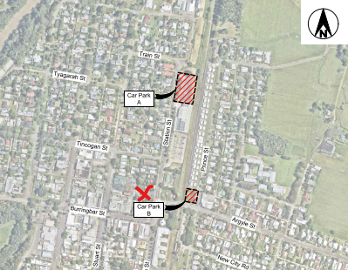
Figure 7 – Station Street car park
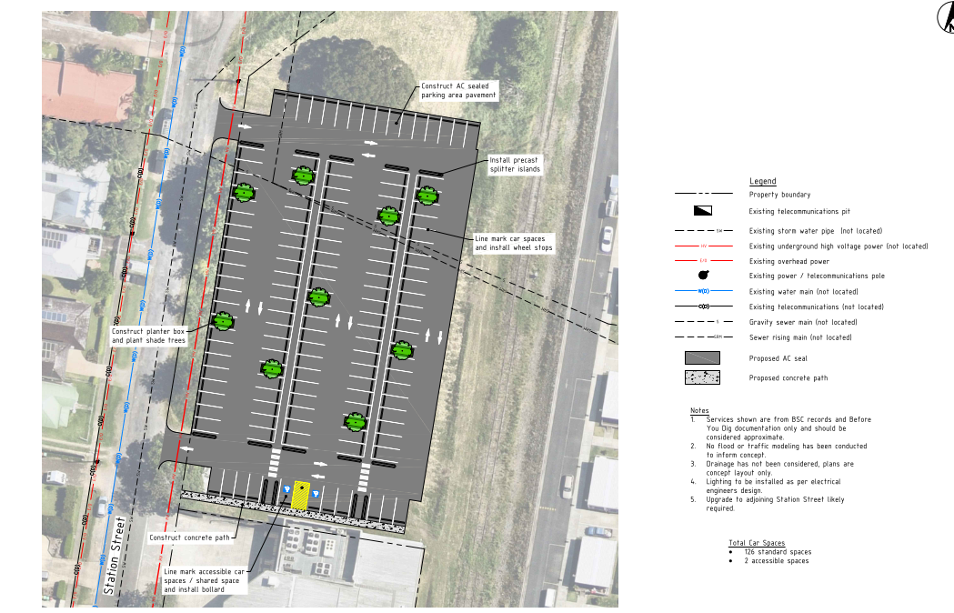
Figure 8 – Prince Street car park
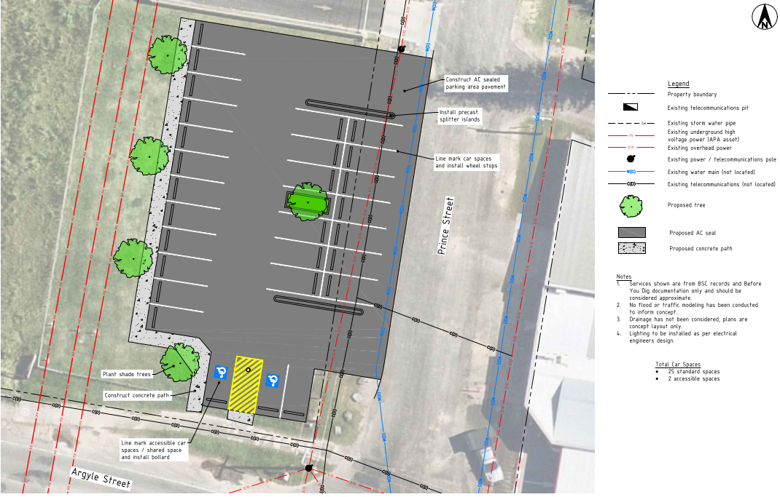

  - Loss of heritage listed public toilets
Two issues are considered below, being, the loss of a locally heritage listed building; and the loss of public toilets.

Heritage
A Heritage listed public toilet (LEP Schedule 5) designed by Byron Bay based architect Christine Vadaz, particularly active in the profession from the 1980’s onward, is located within the subject site.

After consideration of the Statement of Heritage Impact prepared by Everick Heritage; and the comments from Council’s Heritage Advisor; an appropriate strategy to deal with the proposed demolition is to condition the consent requiring: a) an archival report of the heritage item; and b) the preservation of the roof for reuse in a future small scale civic building such as a gazabo or the like, preferably in Mullumbimby. Council’s asset management staff have been informed of the circumstances and short-term storage is possible while an appropriate reuse is decided upon.

The issue is can be resolved with appropriate conditions of consent.
Loss of public toilets

Public toilets available in Mullumbimby town centre include:
- Mullumbimby Tennis Club Recreation Ground – toilets are located within the fenced enclosure and are part of the tennis club. Additionally, public toilets are located outside of the fenced enclosure.
- Mullumbimby Civic Centre Memorial Hall – toilets are available within the building for public use. However, opening times vary depending on a specific concert, market o=r function booked.
- 57 Station Street within the public car park (proposed for demolition) –
- Byron Shire Council Administration building – open within normal office hours

The Byron Shire Local Infrastructure Contributions Plan 2026 came into effect on 1 July 2026. A new Mullumbimby amenities block, including hot showers and solar, is a line item in the plan (Appendix E – Works Map, Table D.3: Community Facilities, Item CF2). At the time of writing, Council’s Business Analyst / Contributions Officer, from Council’s Infrastructure Services Directorate, indicated that a site for the amenities block was yet to be determined, however, it is planned for an “in town” location.

  - Construction and operational traffic and car parking
The DA was supported by the following relevant documentation:
- Traffic Impact Assessment, prepared by Bitzios Consulting – Traffic Engineering & Traffic Planning, dated 21 May 2025;
- Traffic Impact Assessment – Additional Information, prepared by Bitzios Consulting – Traffic Engineering & Traffic Planning, dated 1 June 2026.
The traffic assessment utilised intersection traffic surveys, automatic tube counts (ATC) and Signalling, Integrated Design and Research (SIDRA – micro-analytic traffic evaluation software). ATC was used at McGoughans Lane (80m north of Burringbar Street); Tincogan Street (just east of McGoughans Lane); and Burringbar Street (just east of McGoughans Lane). SIDRA analyses were undertaken for McGoughans Lane / Tingogan Street intersection and McGoughans Lane / Burringbar Street intersection.
Council’s Development Engineer reviewed the traffic reporting and concluded that operational traffic would generate a low impact to the existing road network.
The matter of construction traffic can be dealt with as a condition of consent prior to the issue of a Crown Certificate.
The proposed car parking within the site is accessed from McGoughans Lane and contained within the footprint of the building. Car parking complies with the requirements of SEPP (Housing) 2021 and Byron DCP 2014.

  - Solar access for south facing restaurants
The DA was supported by the following relevant documentation:
- Shadow Analysis – Winter Solstice, prepared by Hill Thalis Architects dated 28/5/26
- Statement of Environmental Effects, prepared by Wilson Planning, dated June 2026

Refer to Aeriel View below of five adjoining southern commercial properties, all within Zone E1 Local Centre.

Aerial view of adjoining southern commercial properties
Note. Number 72 (centre allotment) is currently used as alfresco dining for two restaurants
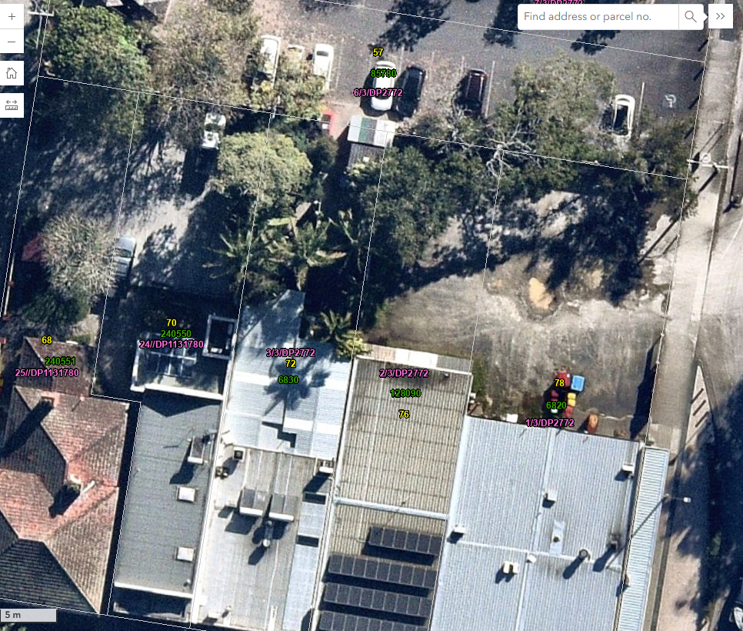
Shadow Analysis – Winter Solstice

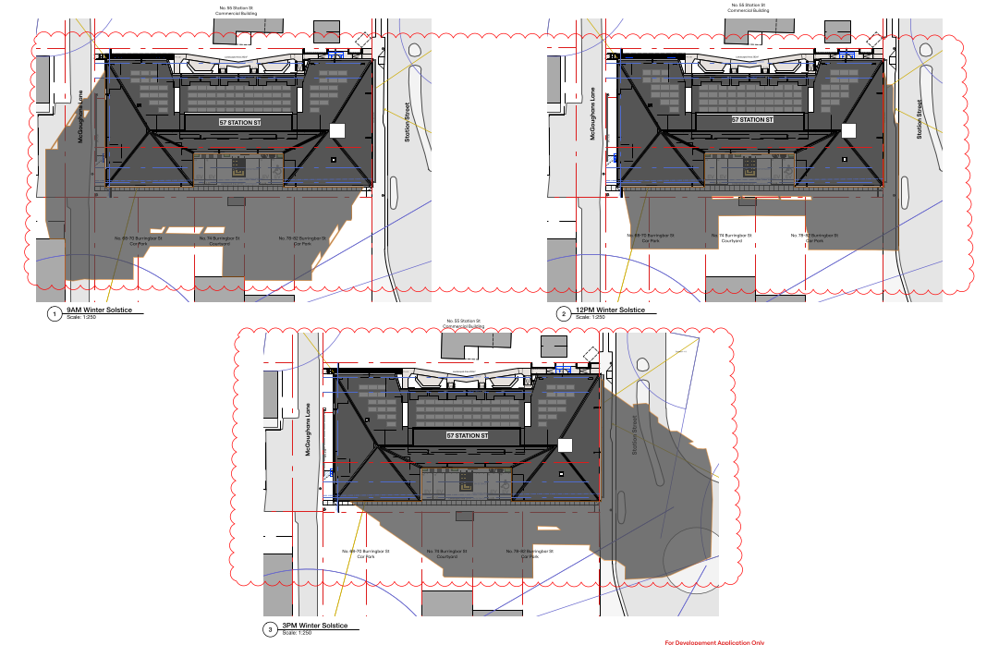

The Apartment Design Guide Section 3B-2 applies – Overshadowing of neighbouring properties is minimised mid-winter. Byron DCP D1.2.1 – Building Height Plane does not apply to shop top housing (refer to Prescriptive Measure 1 of that section of the DCP).
Overshadowing of the adjacent southern properties is minimised during mid-winter.
- The amended DA relocated the entire building 0.7m further from the southern boundary. The southern setback is 3.6m with the central part of the building setback approximately 8m.
- The proposed 3.6m-8m setback from the southern boundary in Zone E1 Local Centre is very generous and serves to minimise overshadowing on the adjacent commercial premises. The northern portion of No. 68, 70, 76 & 78 are all used for private car parking and not for outdoor open space. However, significant portions of the car parking spaces will maintain unimpeded solar access. Additional shade in these locations may even be beneficial for car parking. No 72 is occupied by two restaurants where the vegetated northern portion of the lot is used for alfresco dining. In this location, the adjoining proposed northern building is setback approximately 8m. The alfresco dining area would receive more than 3 hours solar access during the winter solstice. Moreover, most of the solar access is achieved between 10am to 1.30pm, likely peak lunch times for diners.
- The adjacent southern allotments are within an employment zone. Byron DCP Chapter D4 Commercial and Retail Development does not include solar access provisions. Solar access is given a higher priority in residential development.
The assessment of solar access for adjoining southern allotments is considered satisfactory and does not require additional conditions of consent.

  - Business disruption
Several reports were submitted with the DA relating to construction phase operations including:
- Noise Impact Assessment Report, prepared by JHA Services, dated 18/3/2025;
- Geotechnical Investigation Report, prepared by ASCT, dated 25/11/2024;
- Traffic Impact Assessment, prepared by Bitzios Consulting, dated 21/5/2025;
- Waste Management Plan, prepared by MRA Consulting Group, dated 29/6/2026;
- Additional Traffic Assessment Information, prepared by Bitzios Consulting, dated 1/6/2026

Council’s Environmental Officer and Development Engineer have assessed the proposal and reports related to their disciplines and they are satisfied that negative impacts on surrounding existing development can be mitigated with the recommendation of appropriate conditions of consent.

  - Bulk and scale of the building
Various meetings and correspondence with the applicant and their team have occurred subsequent to the initial date of lodgement, being 25/6/2025. The applicant was requested to amend the plans to, inter alia, relocate the building off the sewer main and to reduce the bulk and scale of the building from the Station Street façade. An amended DA was lodged on 16/6/2026. The amended DA satisfied various requests for additional information and relocation of the building further to the north away from the sewer main. However, the Station Street façade was generally not modified.
A further request to amend the plans to reduce the Station Street façade bulk and scale was issued to the applicant on 15/7/26; and followed up with a meeting on 25/9/2026; and amended plans were submitted to Council on 29/9/2026. The amended plans have generally addressed the Station Street bulk and scale matter with: the elimination of part of the second level verandah; increased front setback; and footpath and landscaping works in Station Street. Additionally, the use of F/C cladding or similar with a soft colour palate, via a recommended condition of consent, will also be used to clad the building in association with the proposed galvanised iron and masonry. These modifications are more compatible with the aesthetic character of the Mullumbimby Heritage Conservation Area.

- CONCLUSION

This development application has been considered in accordance with the requirements of the EP&A Act and the Regulations as outlined in this report. Following a thorough assessment of the relevant planning controls, issues raised in submissions and the key issues identified in this report, it is considered that the application can be supported.

The proposed development is consistent with the provisions of the relevant SEPP’s, the Apartment Design Guide, LEP 2014 and DCP 2014. The key issues associated with the development proposal have either been addressed with amended plans; conditions of consent or other actions outlined in section 5 of this report. Council does have plans in place for additional car parking and public toilets in Mullumbimby.

The proposed development is well suited to this central township site. Merit assessment of alternative sites is beyond the scope of this report. Whilst an alternative design with a lower profile to Station Street would be welcome, the building has been carefully designed with the amenity of residents being a major consideration as evidenced with the landscaped area on the northern boundary.

Further landscaping within the public domain is also proposed and the front elevation to Station Street provides a degree of articulation to break up this section of the development. It is noted the Crowns ability to override the recommendations of the assessment report under Division 4.6 of the EPA Act 1979 and need for Crown to sign off on conditions of consent. It is noted the general strategic direction for the construction of more housing across NSW regardless of local planning controls by the NSW State government as evidenced by the establishment of the Housing Delivery Authority.

The proposed mixed-use development including twenty four affordable shop top housing apartments and four boarding house rooms is considered to be in the public interest and the proposal on balance is considered acceptable and is recommended for approval.

- RECOMMENDATION

That the Development Application DA 10.2025.212.1 for Amended DA - Demolition of public toilets (heritage item), car park and tree removal. Affordable housing mixed use development comprising shop top housing (28 apartments above ground level), one ground floor commercial premises and ground floor boarding house, carparking, landscaping and associated services at 57 Station Street Mullumbimby, be APPROVED pursuant to Section 4.16(1)(a) of the Environmental Planning and Assessment Act 1979 subject to the Conditions of Consent attached to this report at Attachment A.

The following attachments are provided:
- Attachment A: Conditions of consent
- Attachment B: Apartment Design Guide Compliance Table
- Attachment C: Architectural and Civil Plans
- Attachment C1: Additional Flood Assessment
- Attachment D: Public Submissions Review

